Discover Himachal Pradesh with INTRO TRAVELS INDIA 🇮🇳🏔️✨
Himachal Pradesh, nestled in the lap of the Himalayas, is one of India’s most beautiful mountain destinations. Famous for snow-covered peaks, scenic valleys, adventure sports, hill stations, rivers, temples, and peaceful landscapes, Himachal Pradesh offers the perfect escape for nature lovers, honeymooners, families, and adventure seekers.
From the colonial charm of Shimla to the adventure paradise of Manali and the spiritual beauty of Dharamshala, Himachal Pradesh promises unforgettable travel experiences throughout the year.

Why Visit Himachal Pradesh?
- Stunning Himalayan mountain views
- Famous hill stations & valleys
- Snowfall & winter experiences
- Adventure sports & trekking
- Beautiful rivers & waterfalls
- Peaceful monasteries & temples
- Scenic road trips
- Perfect for honeymoon & family holidays

Top Tourist Attractions in Himachal Pradesh
1. Shimla
The capital city of Himachal Pradesh and one of India’s most popular hill stations.
Top attractions:
- Mall Road
- Ridge Ground
- Kufri
- Christ Church
- Jakhoo Temple
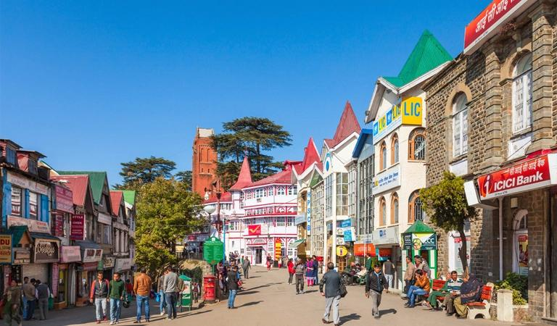
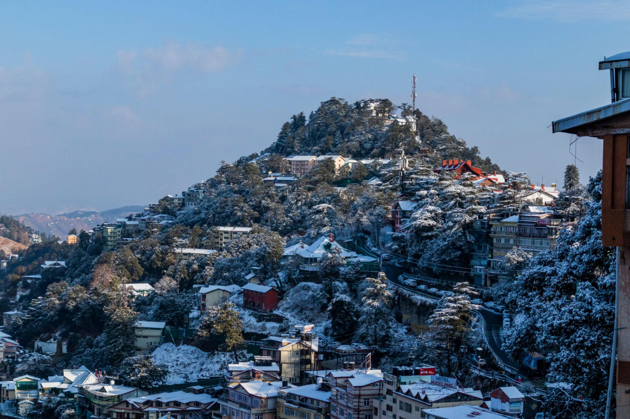
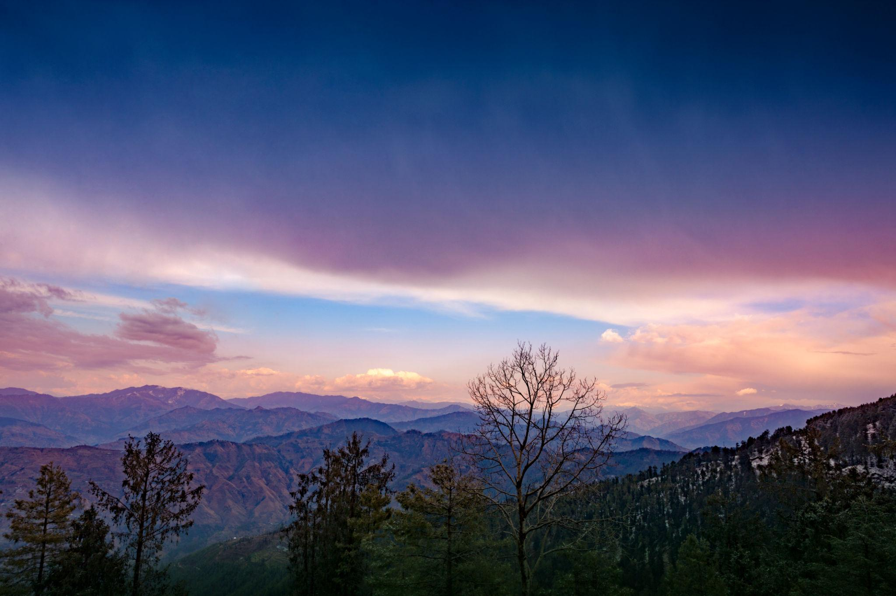
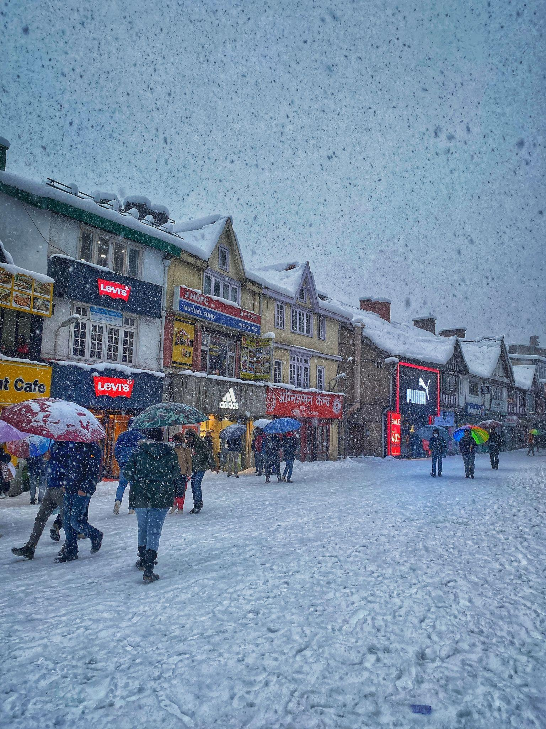
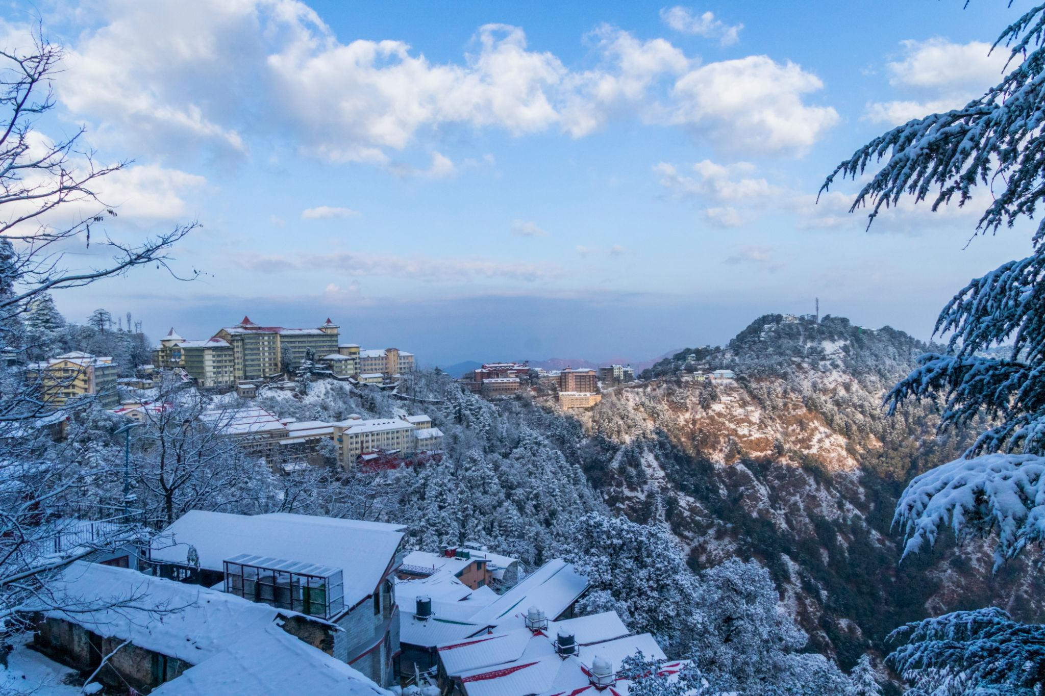
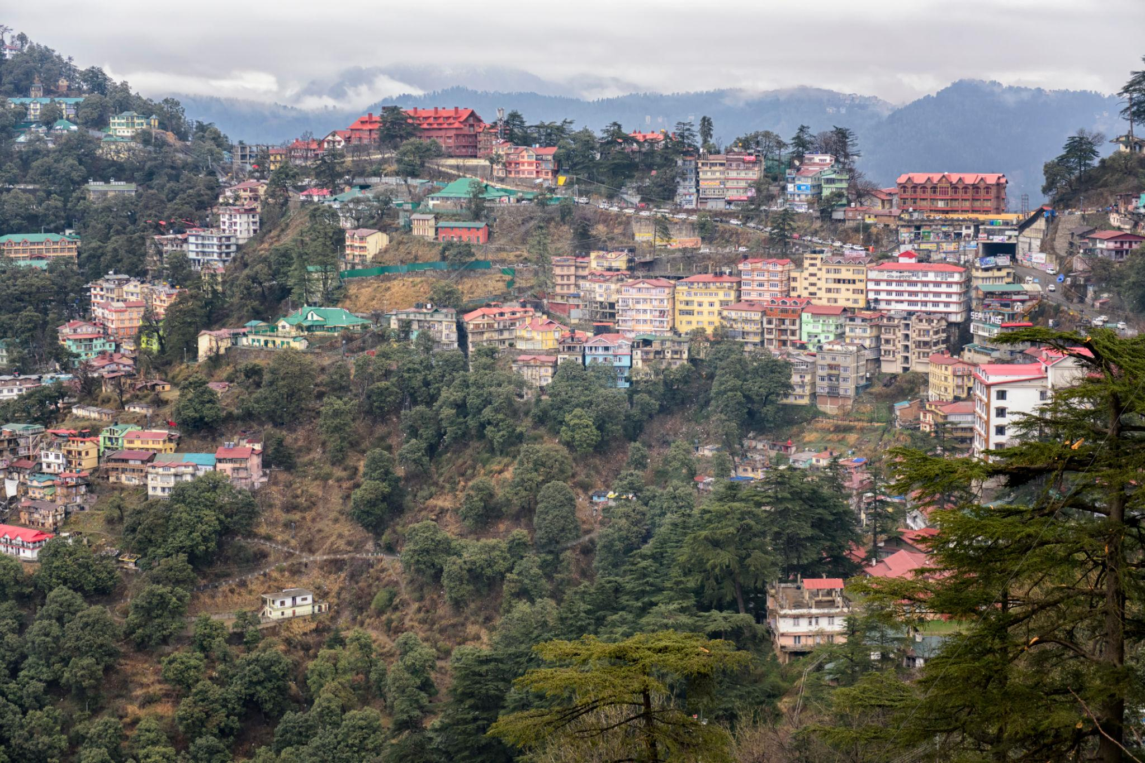
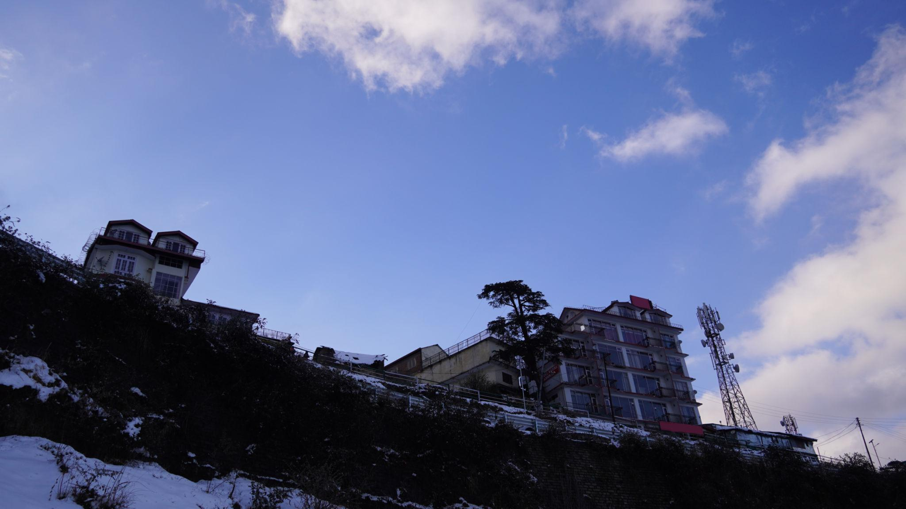

2. Manali
A breathtaking mountain destination famous for snow, adventure activities, and scenic valleys.
Known for:
- Solang Valley
- Rohtang Pass
- River rafting
- Paragliding
- Honeymoon tourism
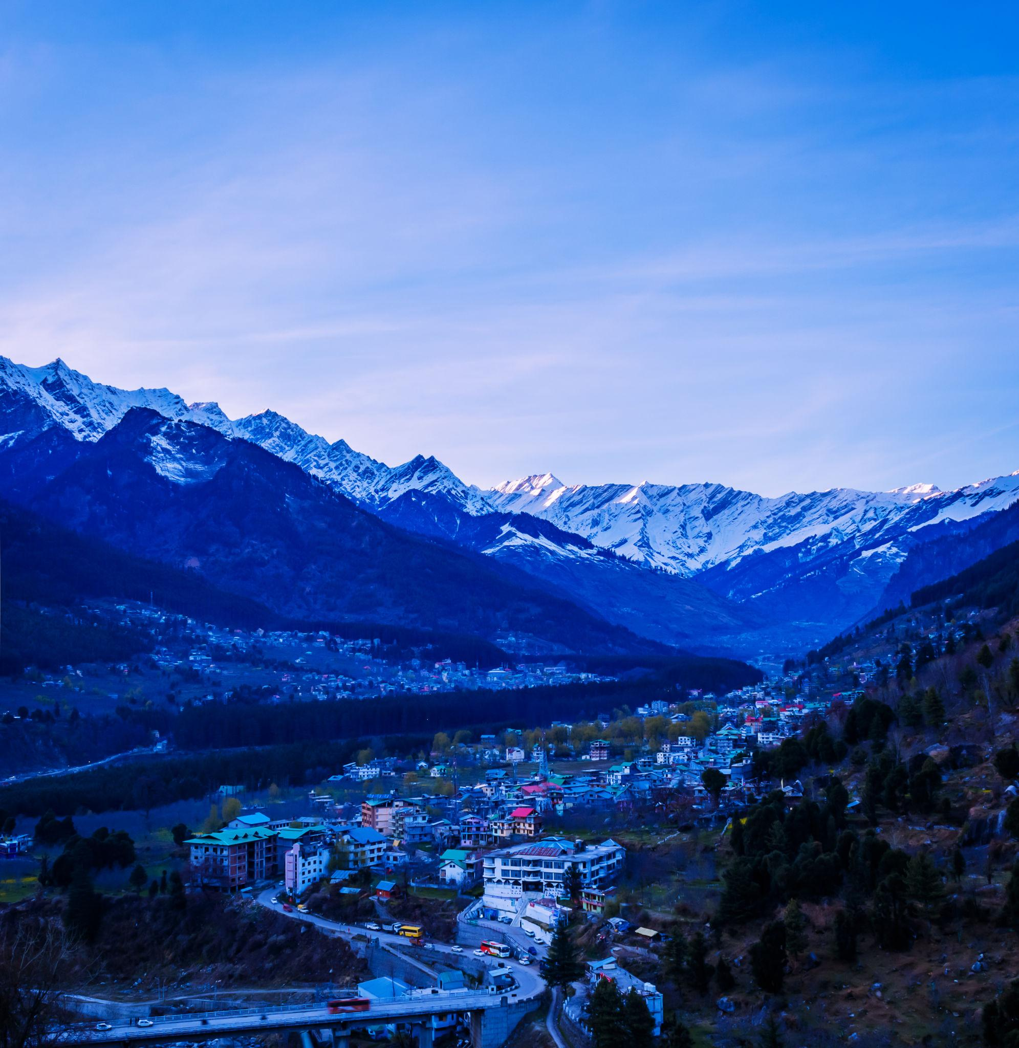
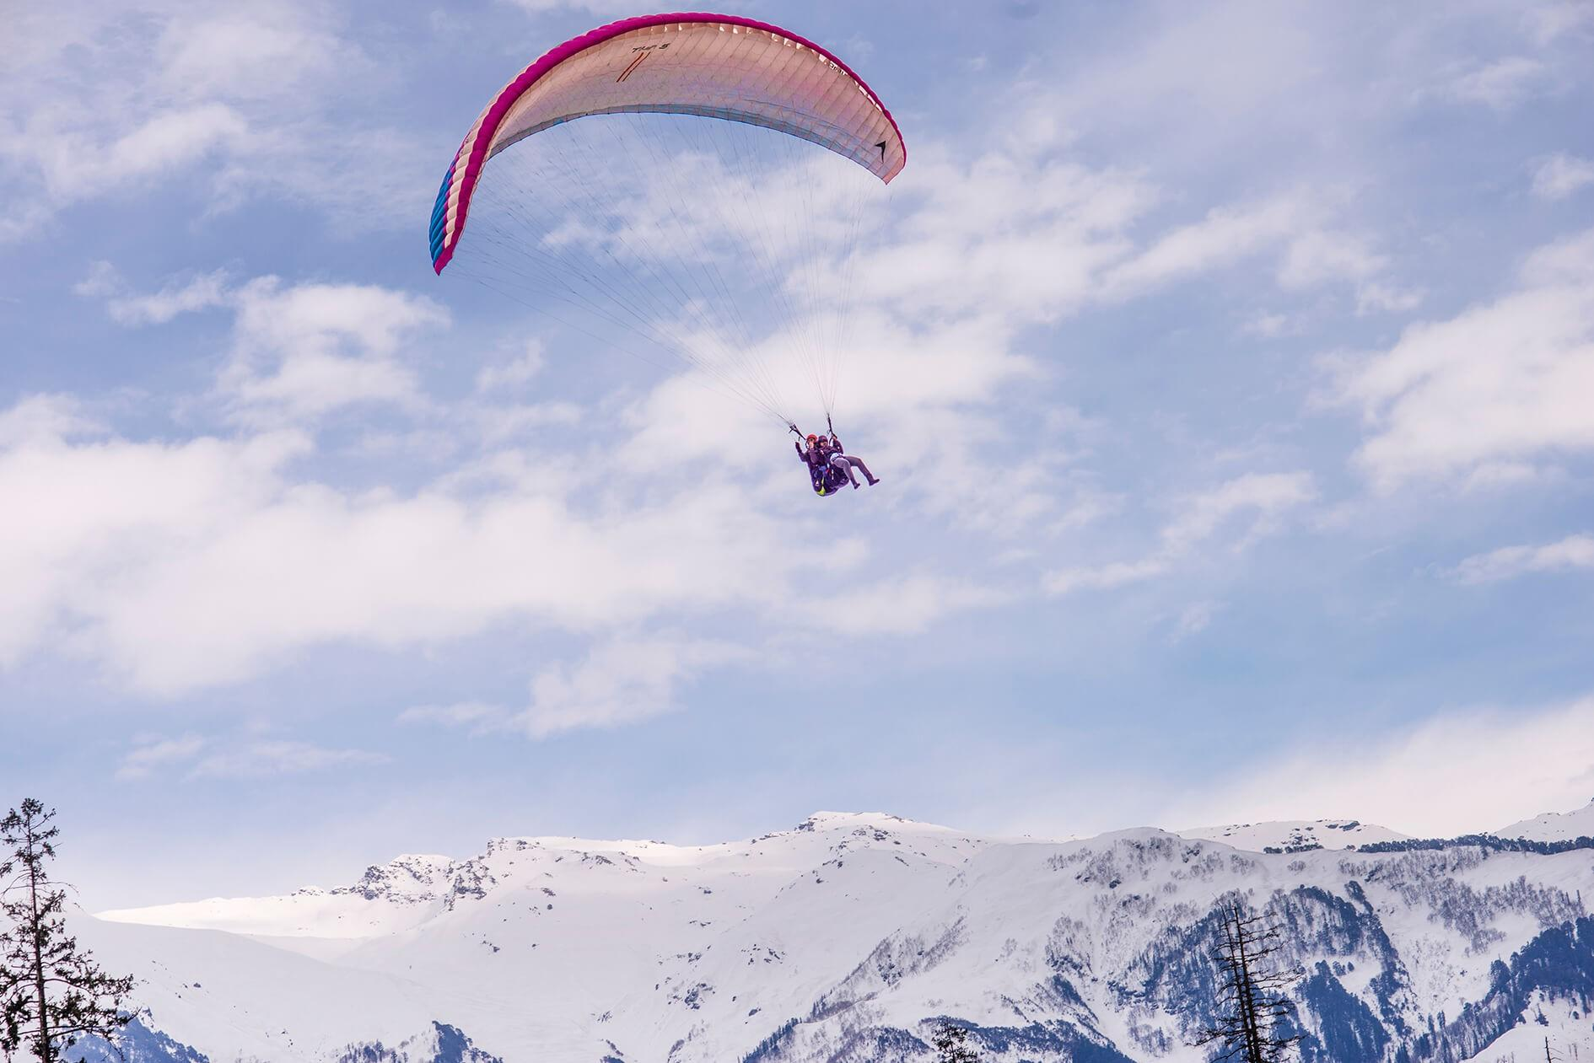
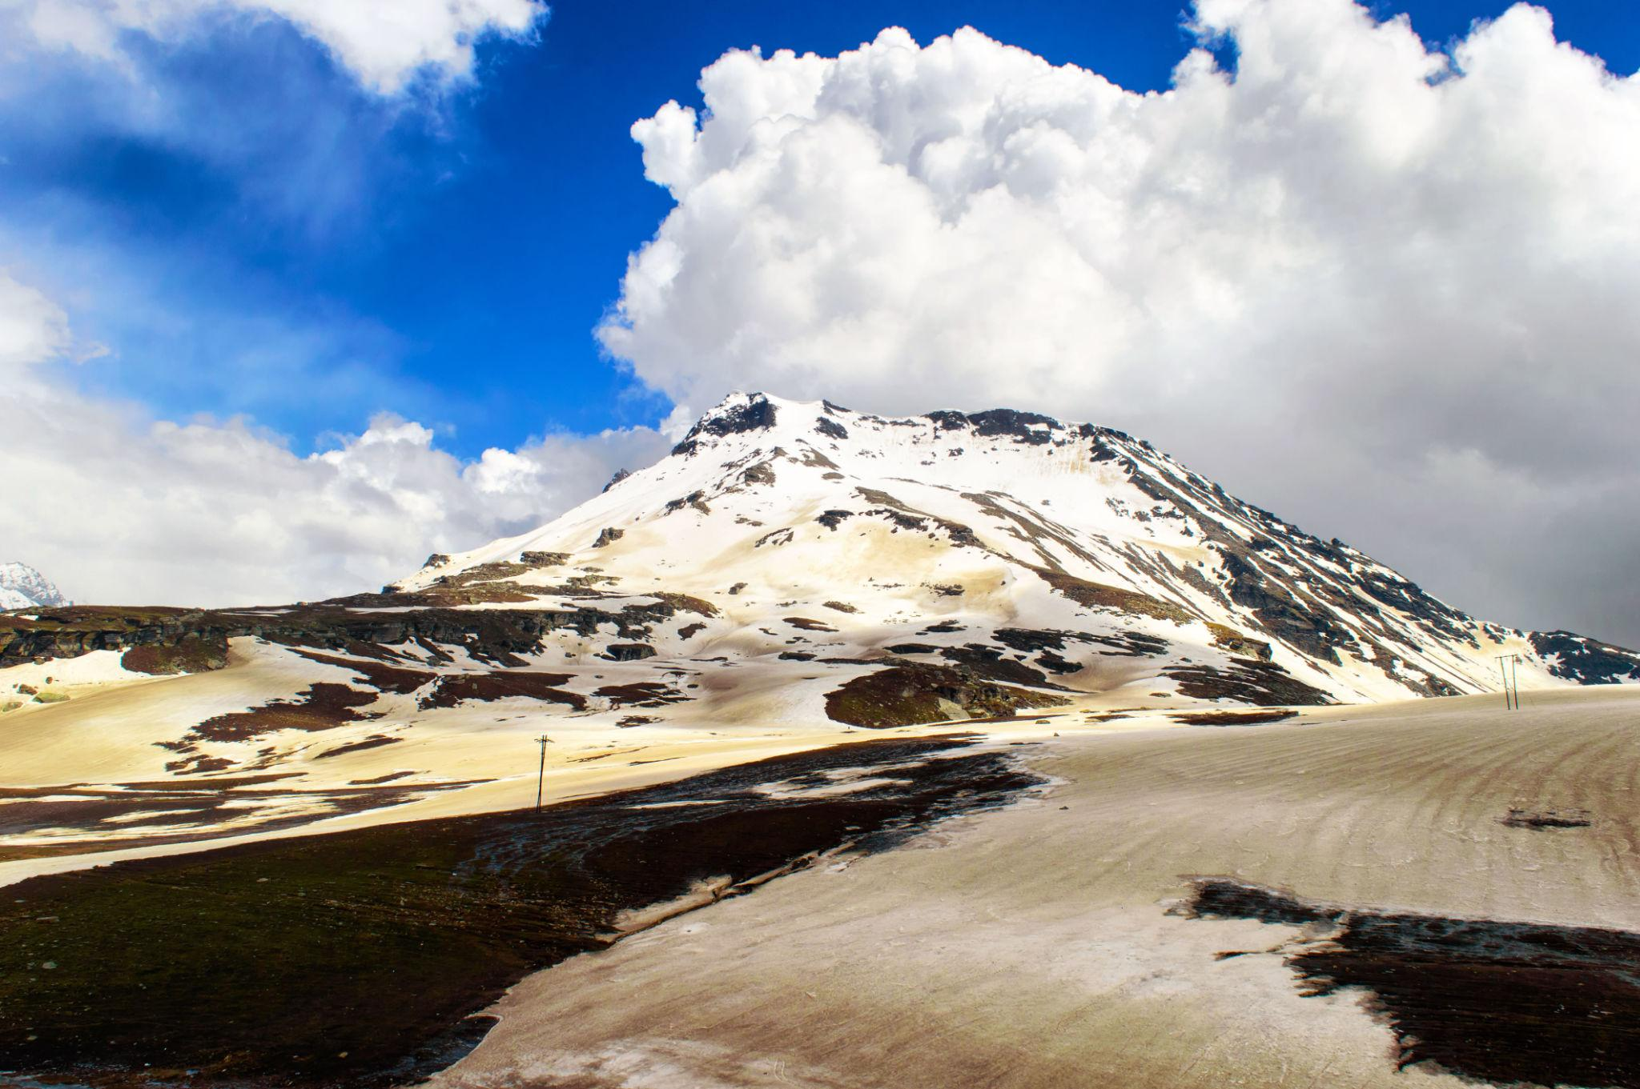
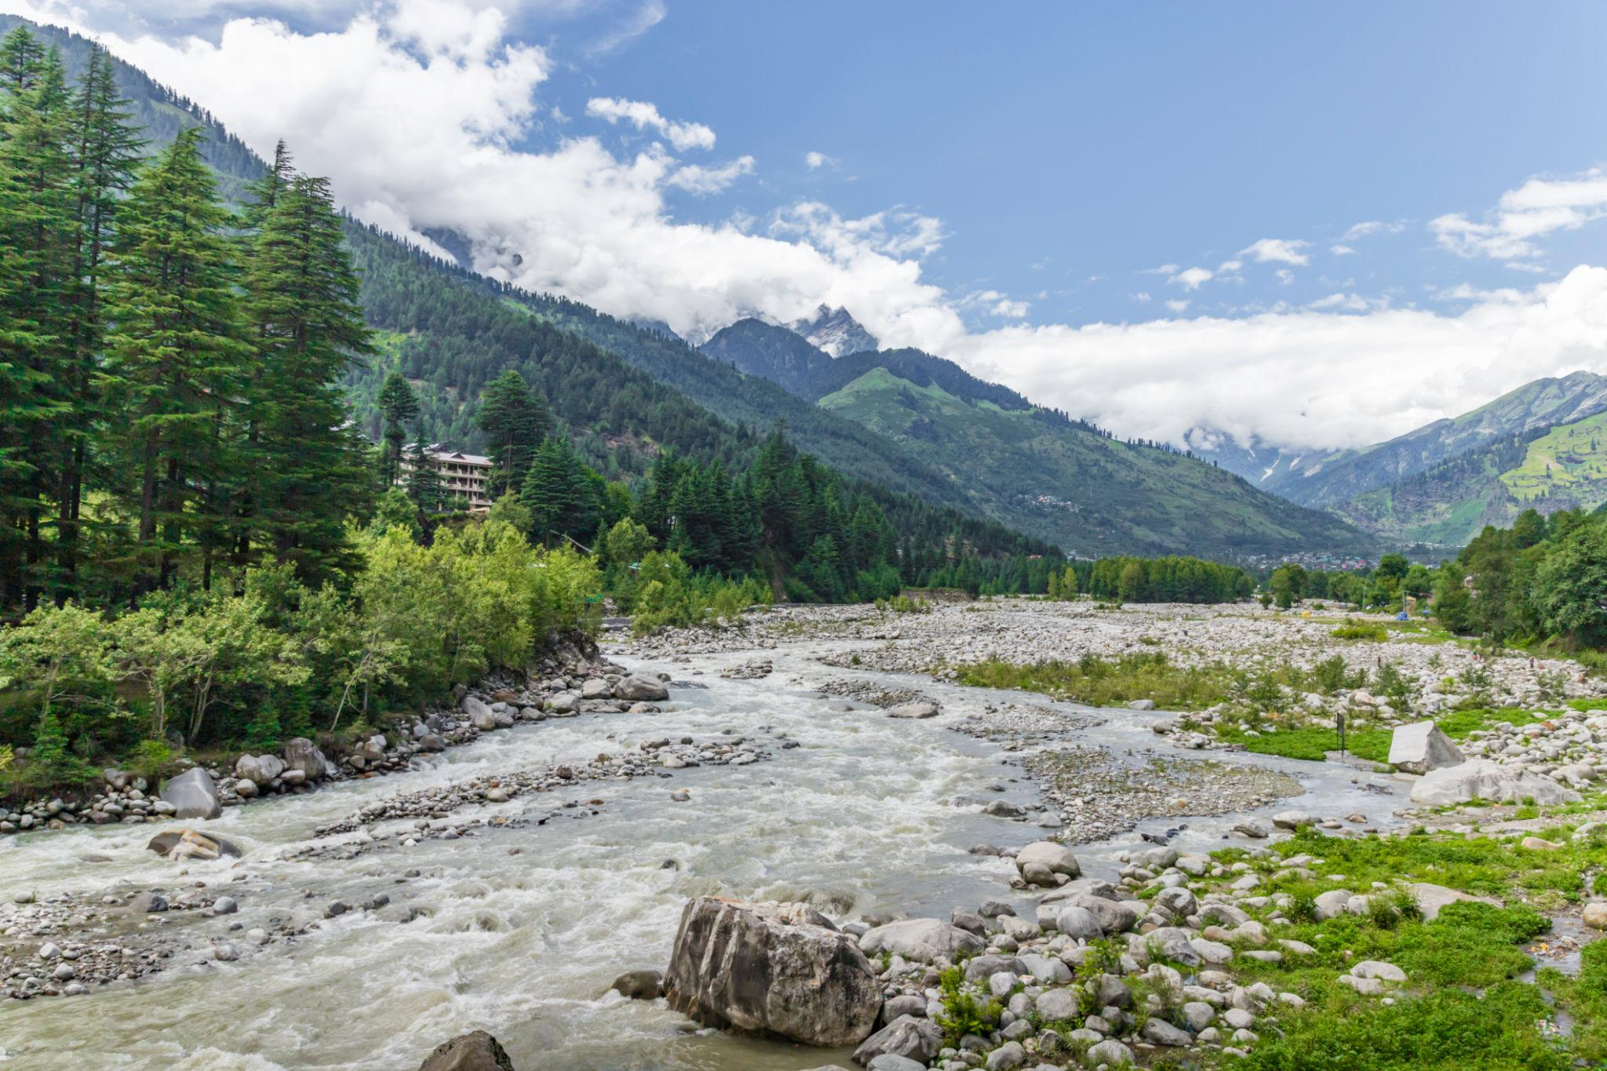
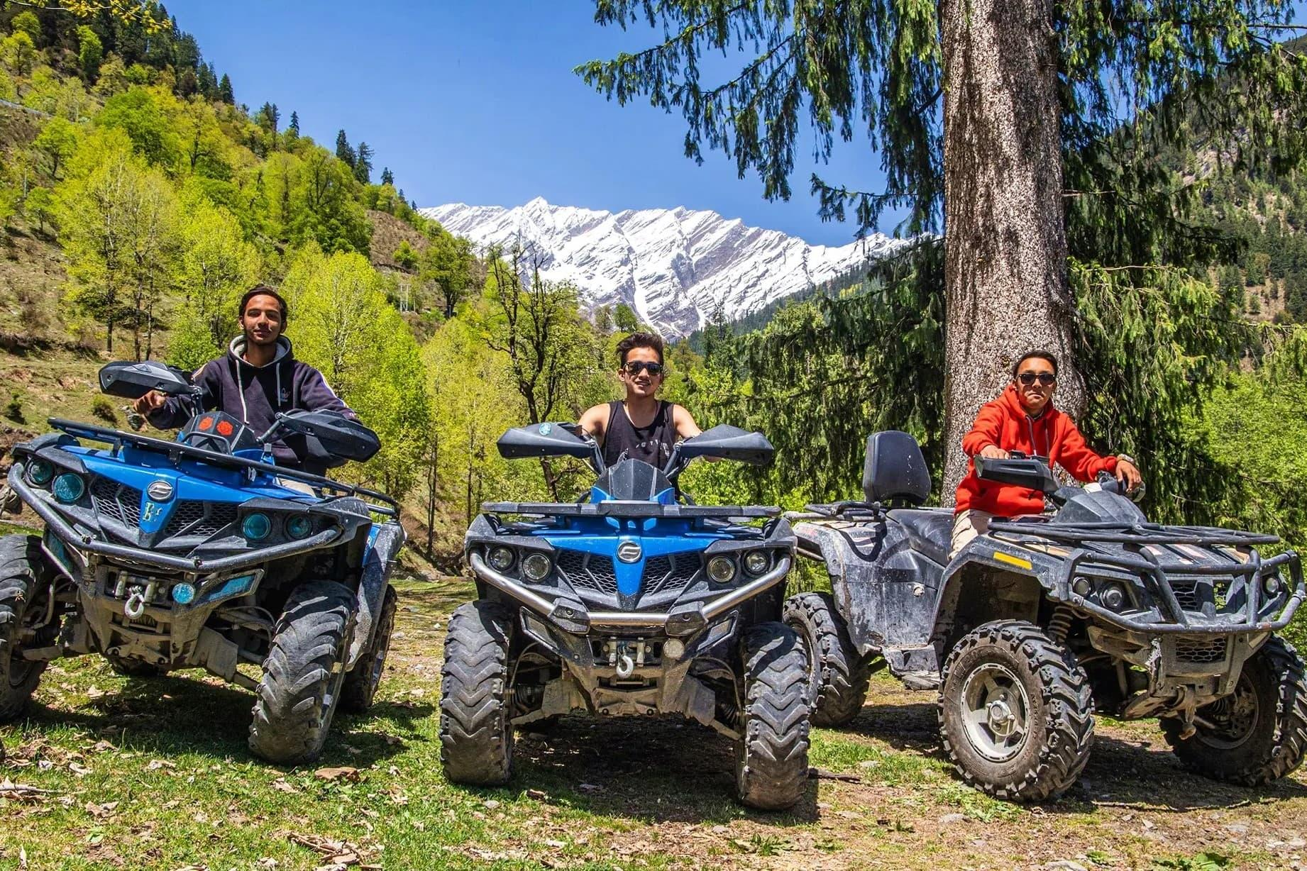
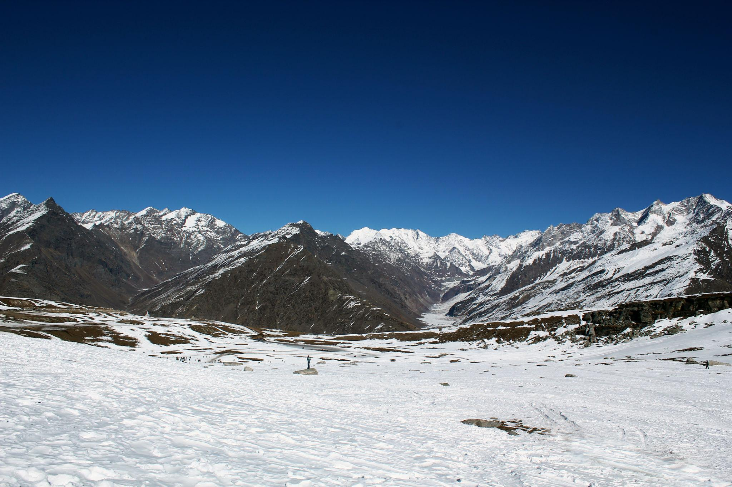

3. Dharamshala
A peaceful hill town known for Tibetan culture and monasteries.
Highlights:
- Dalai Lama Temple
- McLeod Ganj
- Tibetan markets
- Mountain cafés
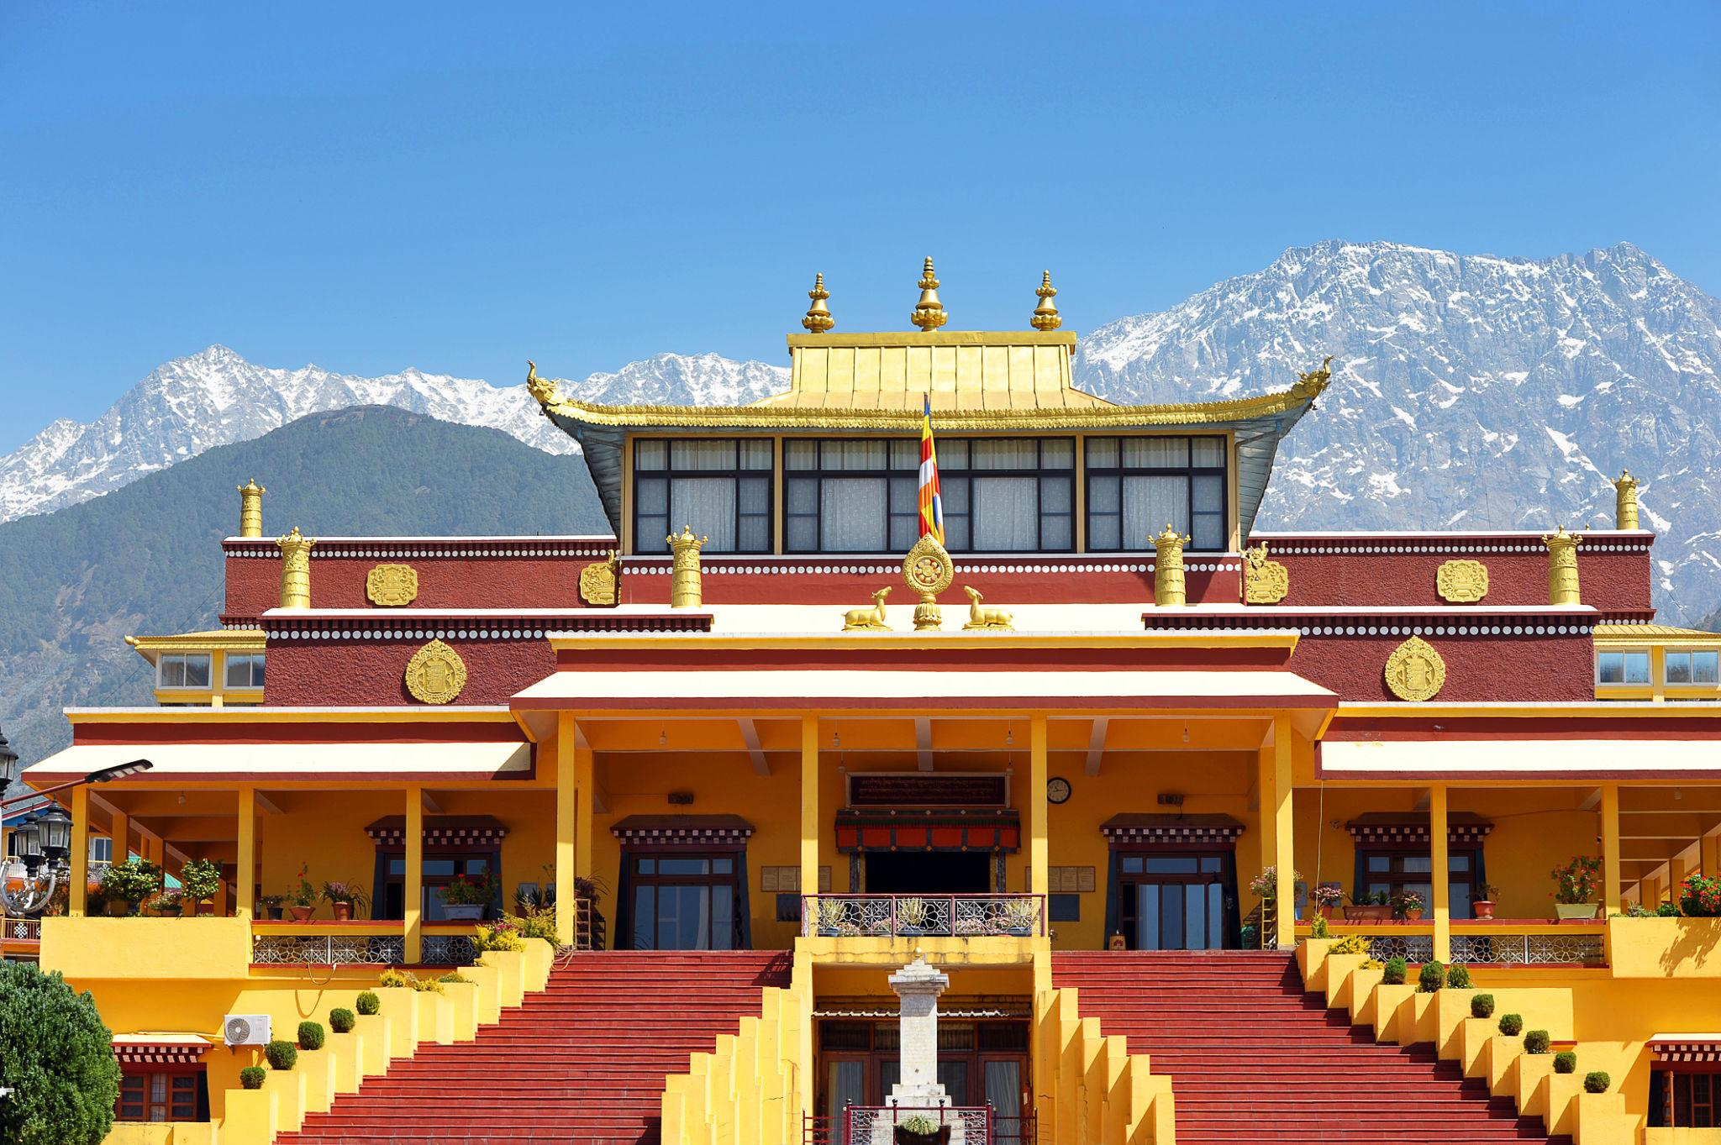
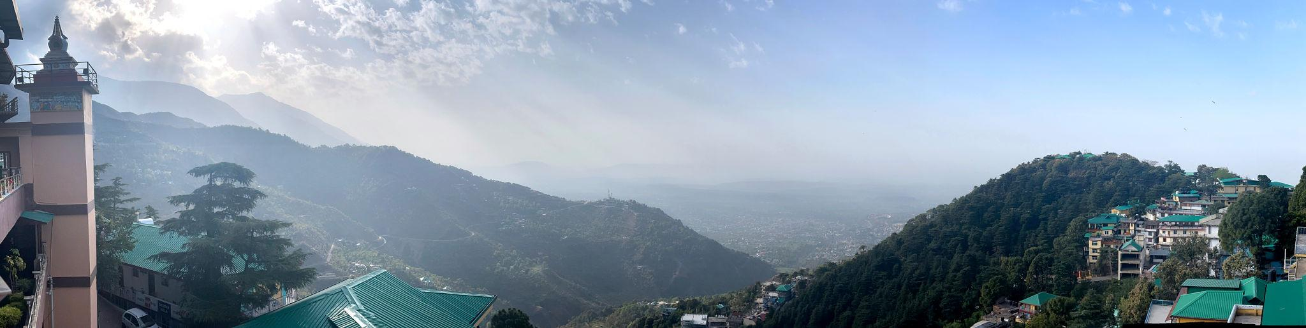
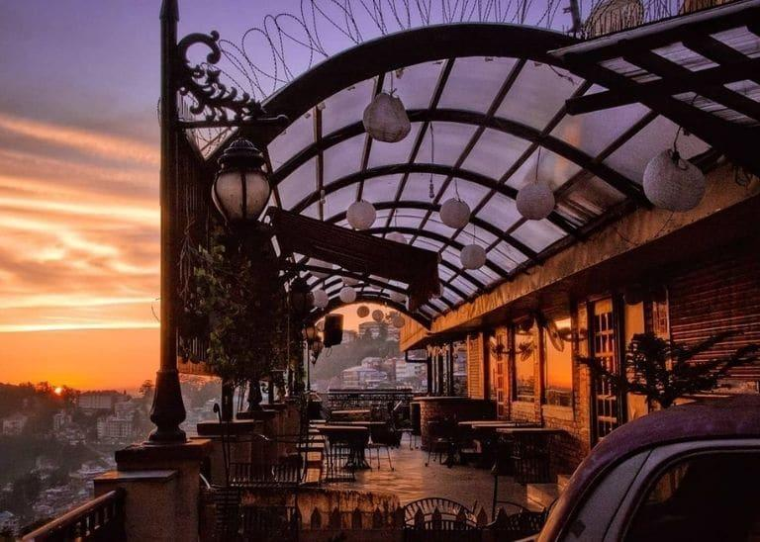
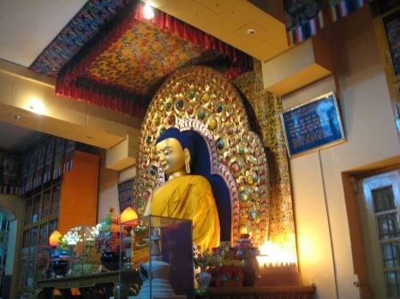
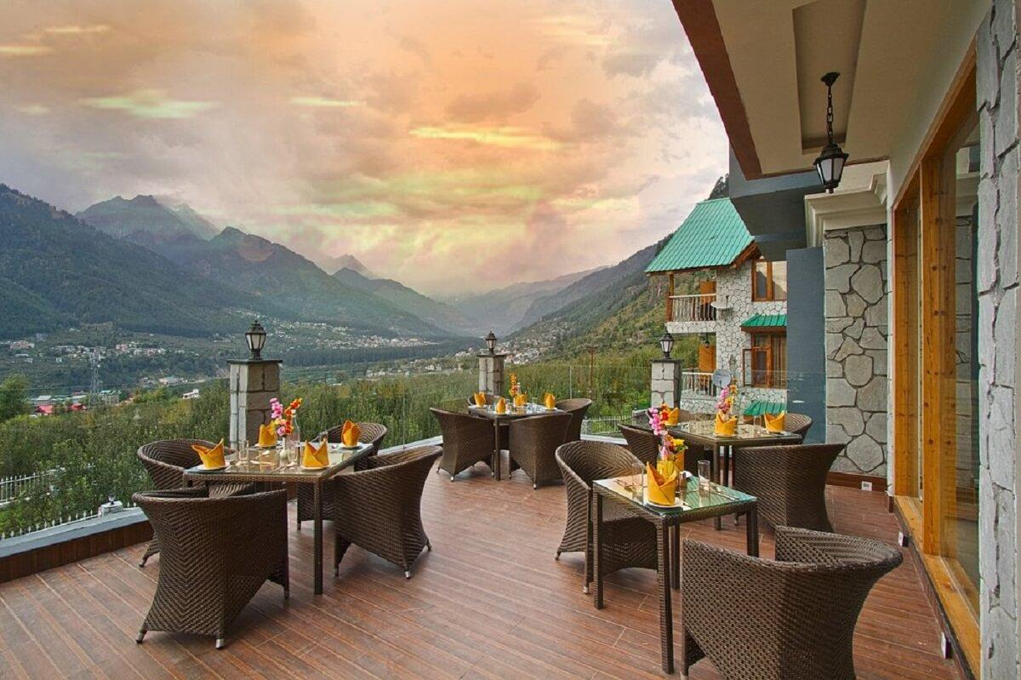
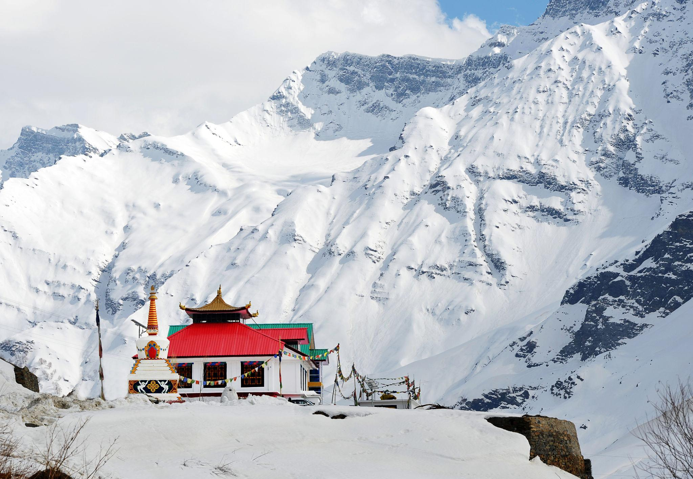

4. Kasol
A scenic riverside village known as the “Mini Israel of India.”
Best experiences:
- Riverside camping
- Trekking
- Café culture
- Nature walks
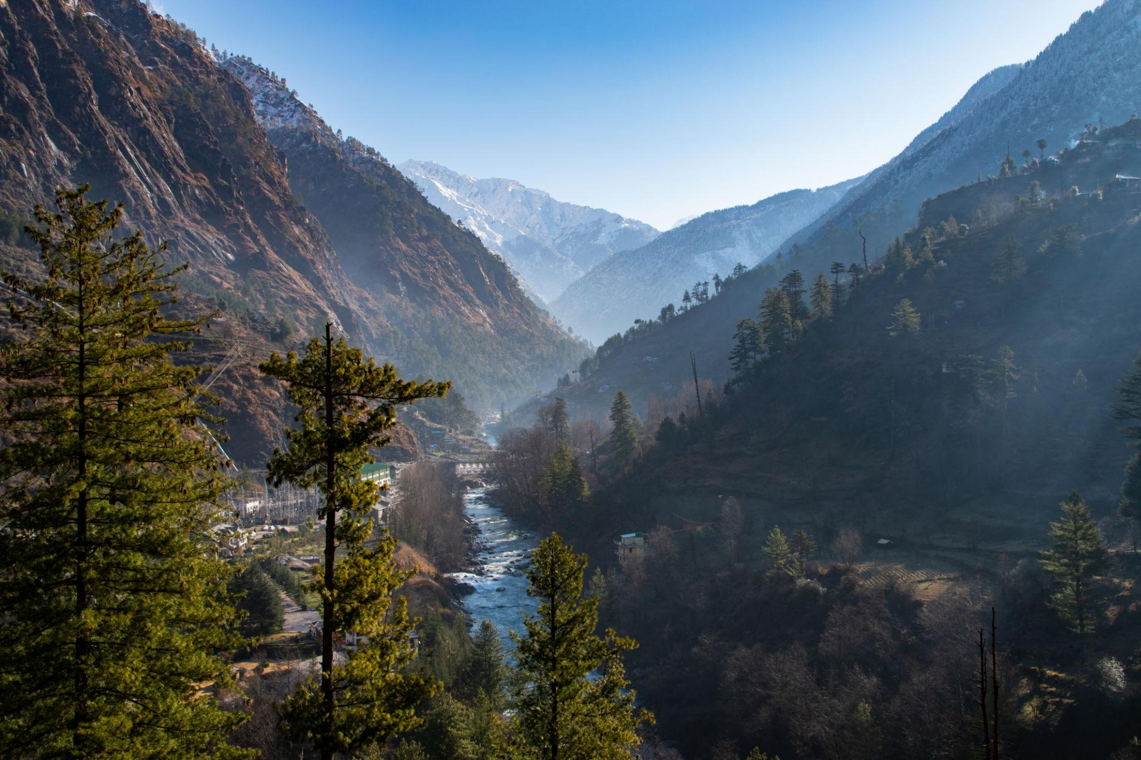
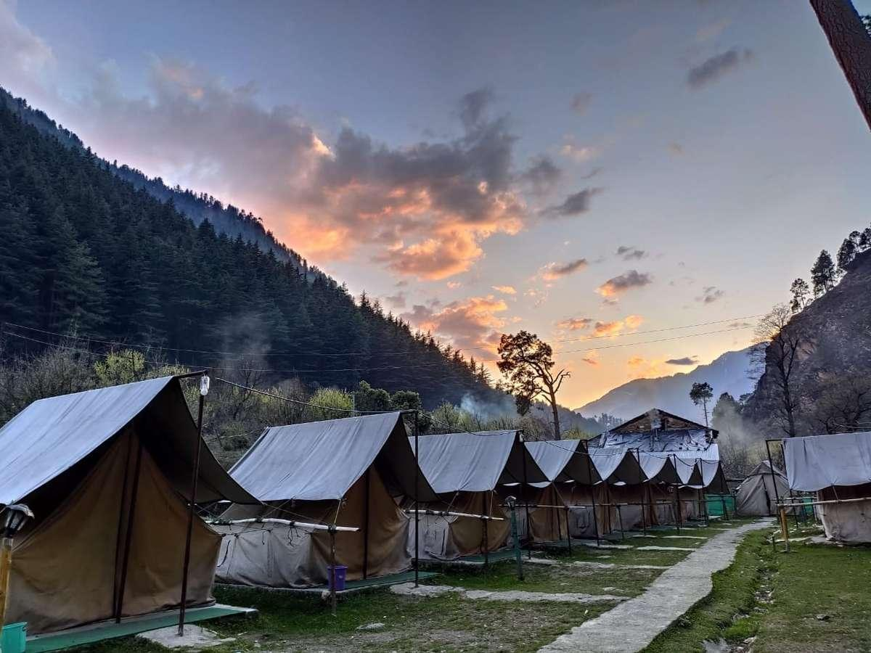
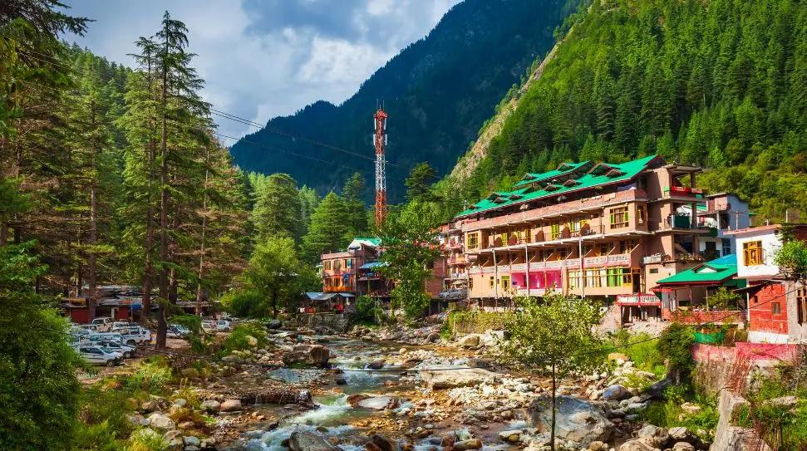
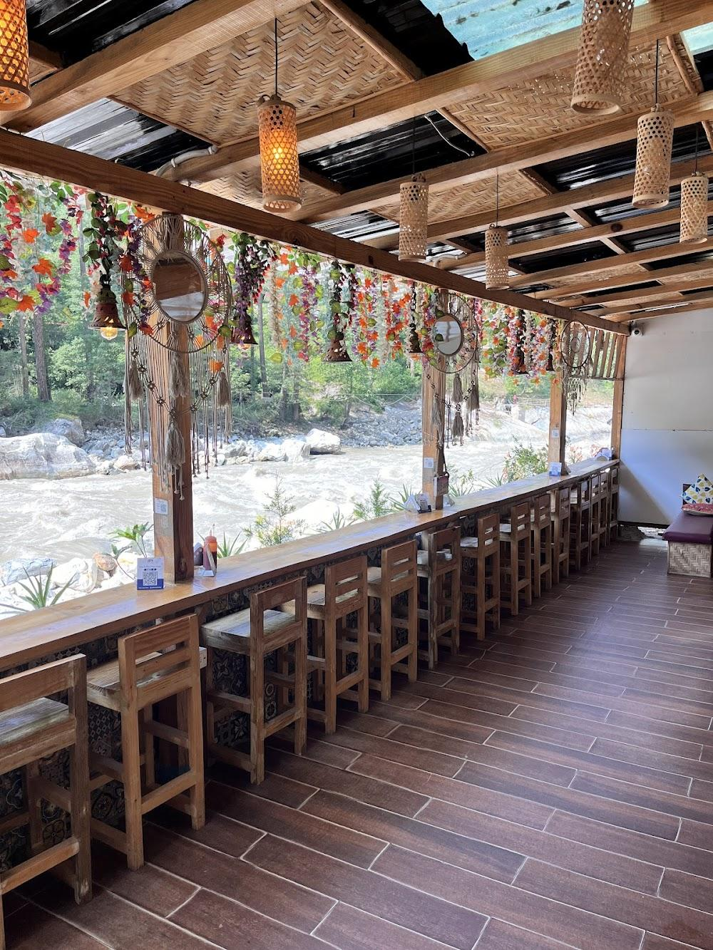
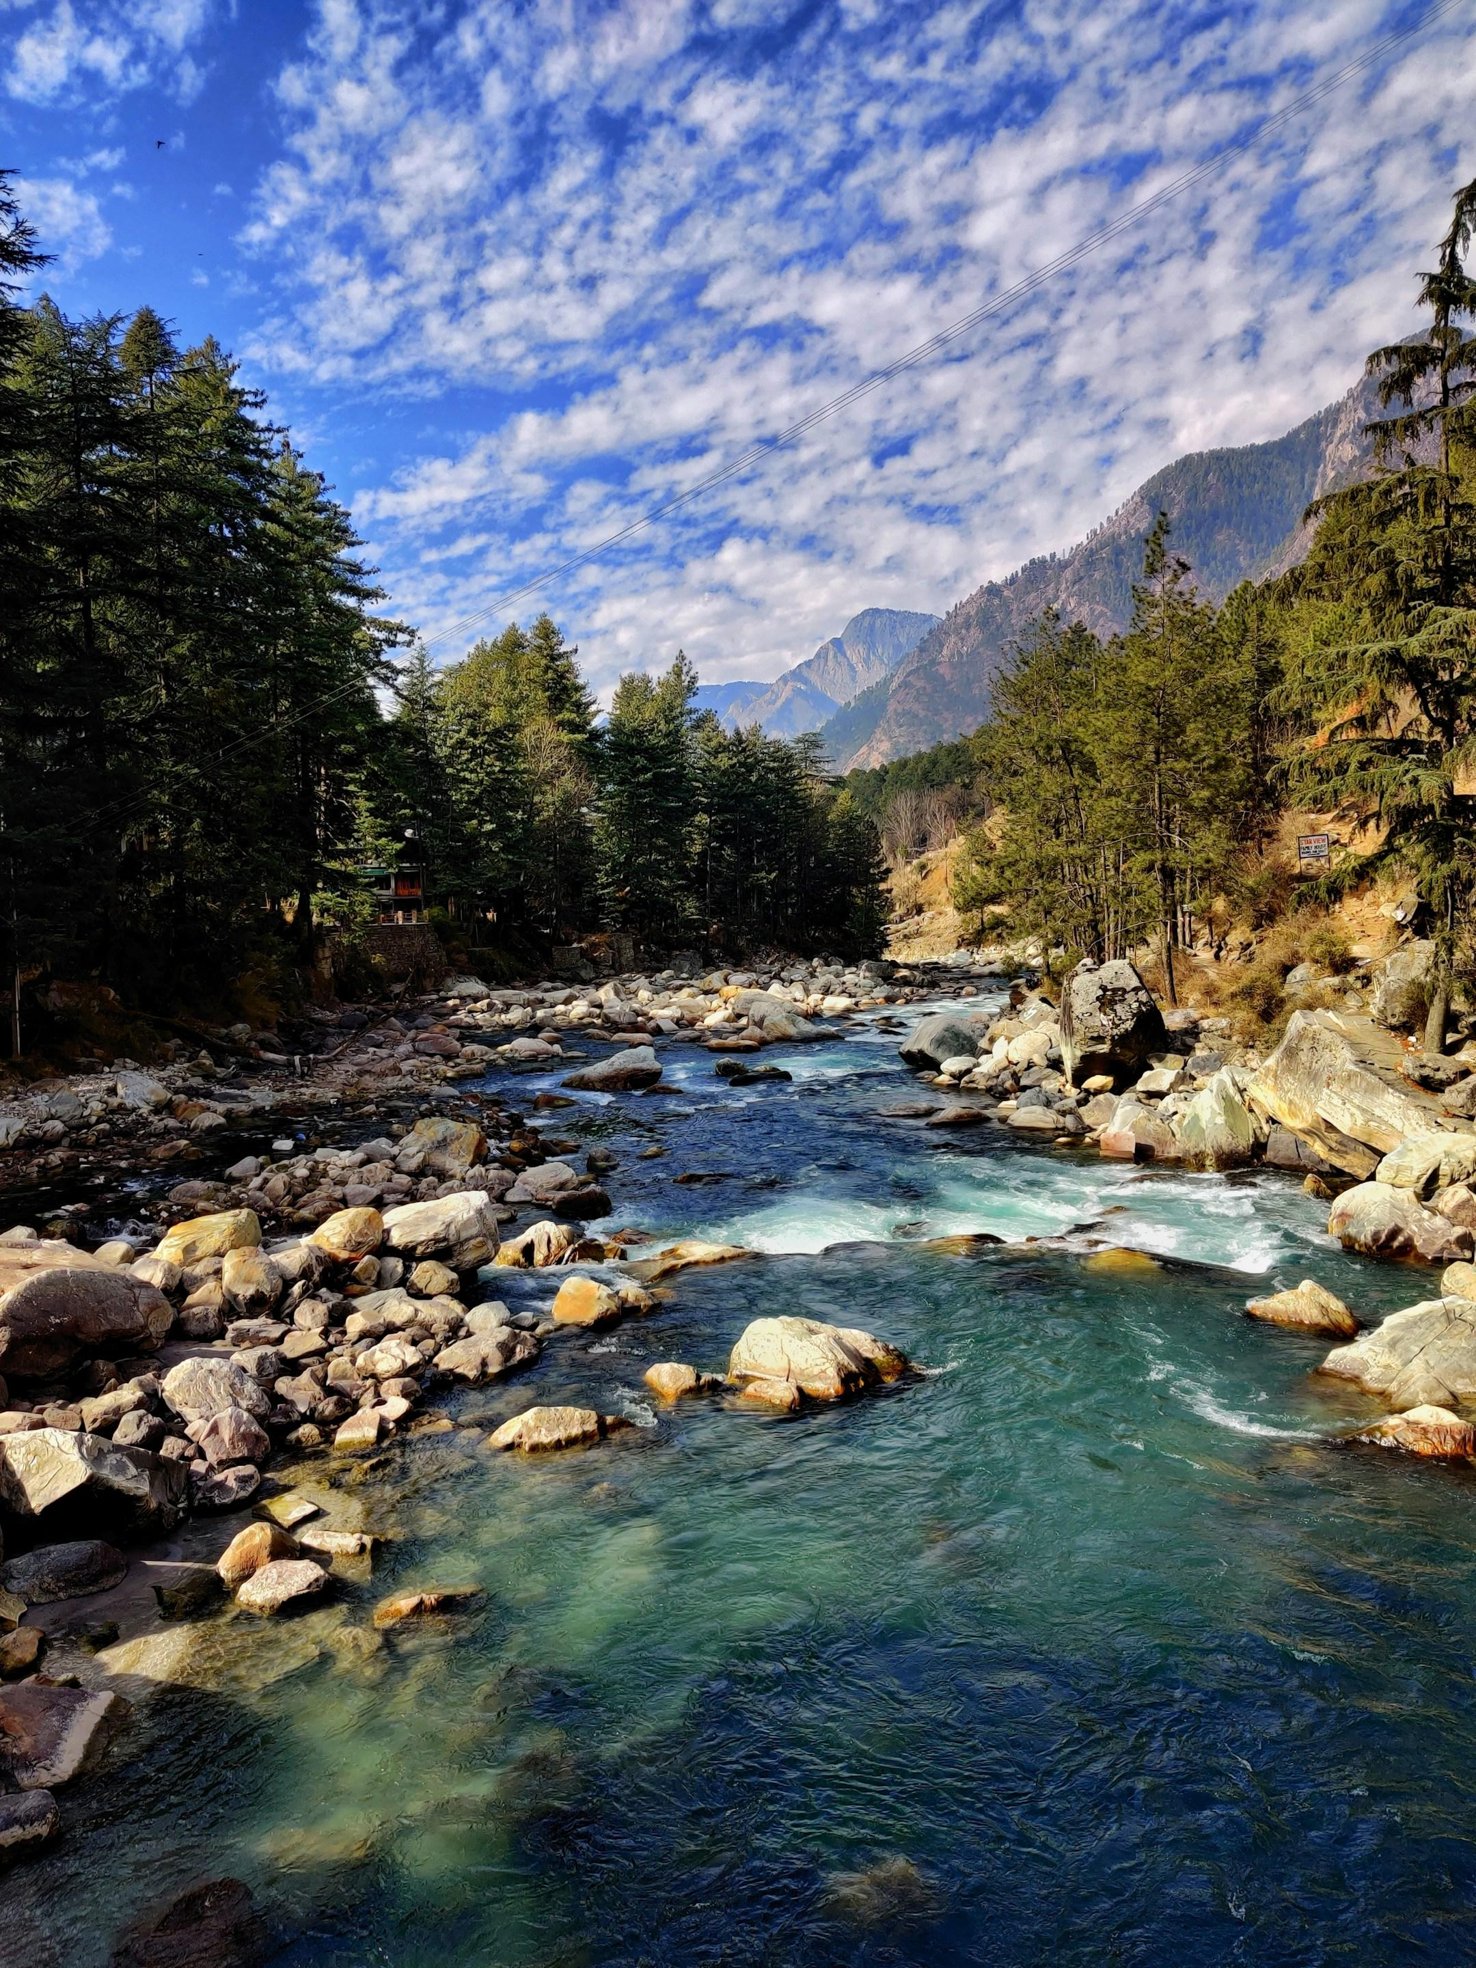
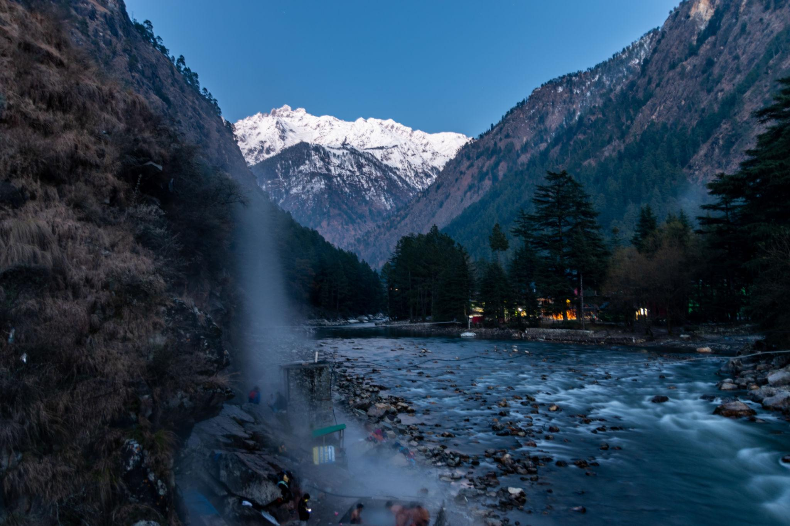
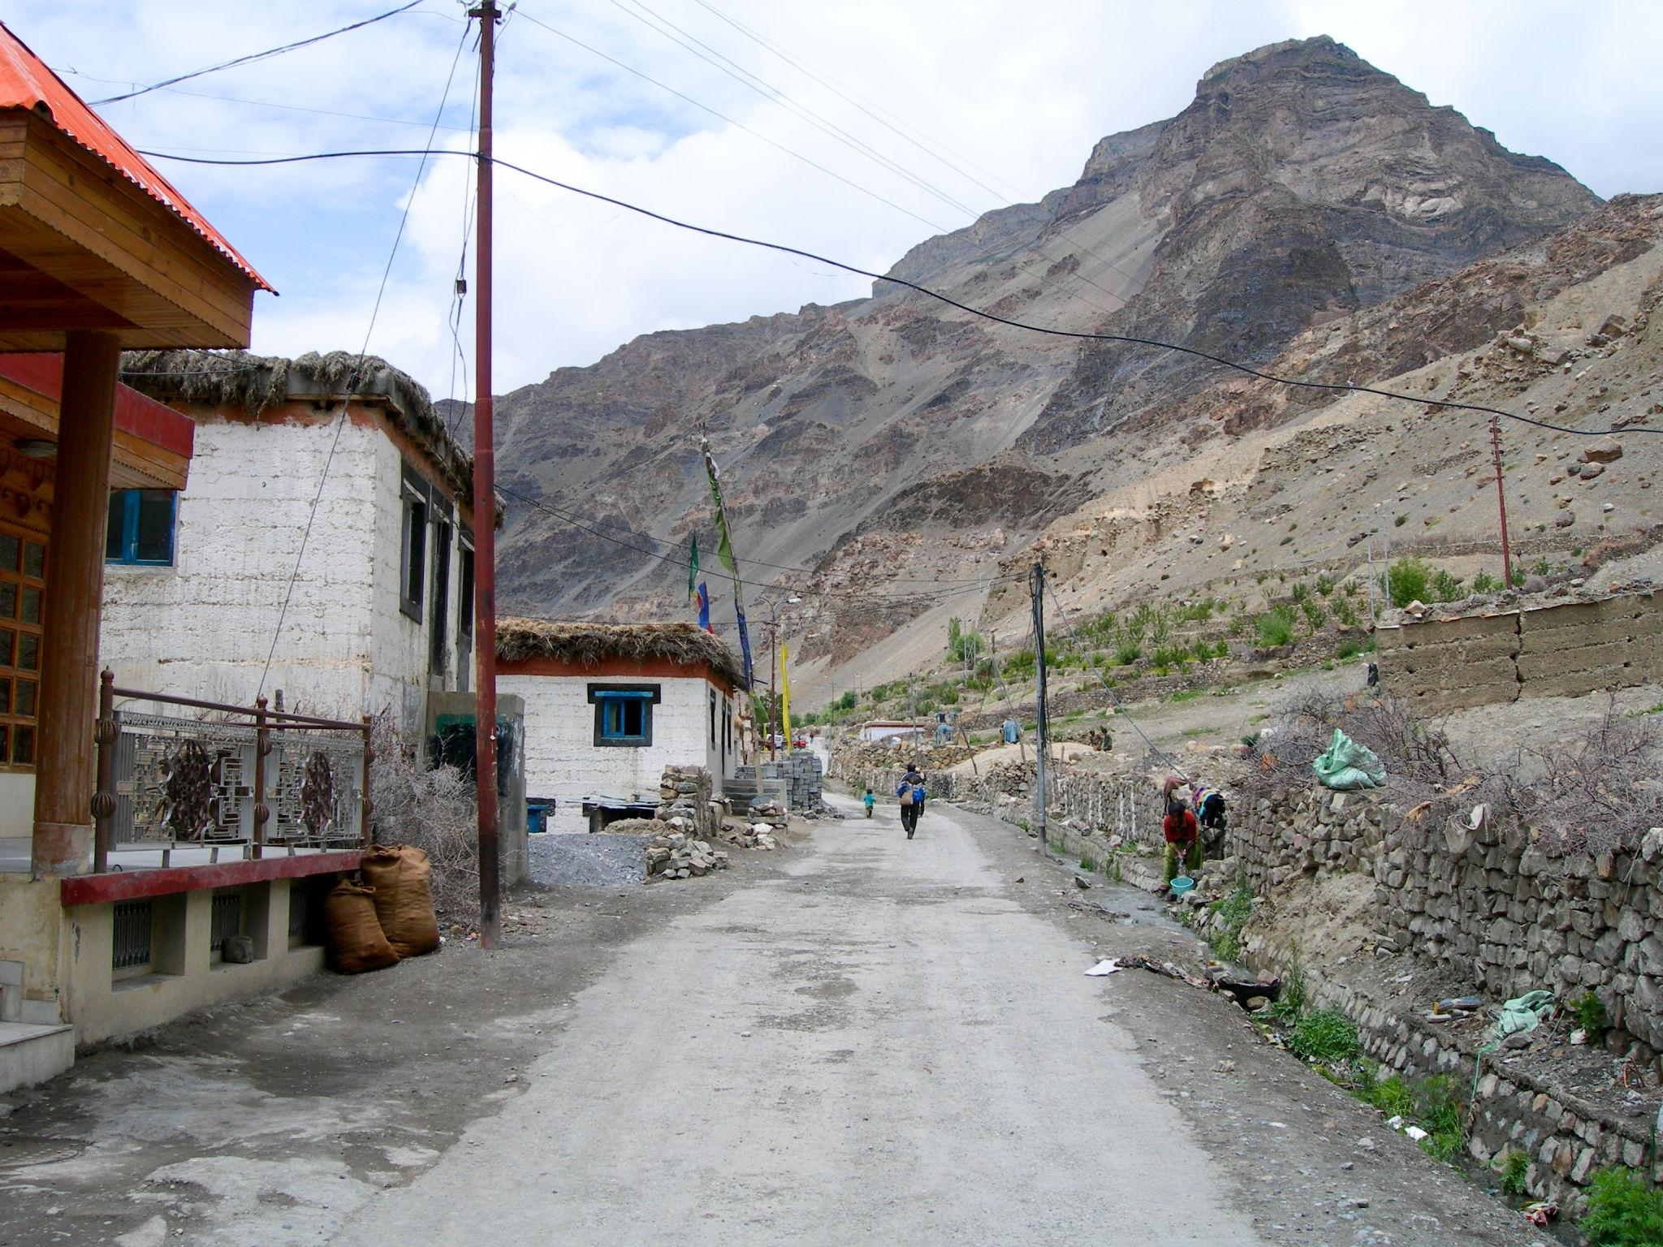

5. Spiti Valley
A cold desert mountain valley famous for dramatic landscapes and monasteries.
Popular attractions:
- Key Monastery
- Chandratal Lake
- High-altitude villages
- Scenic road trips
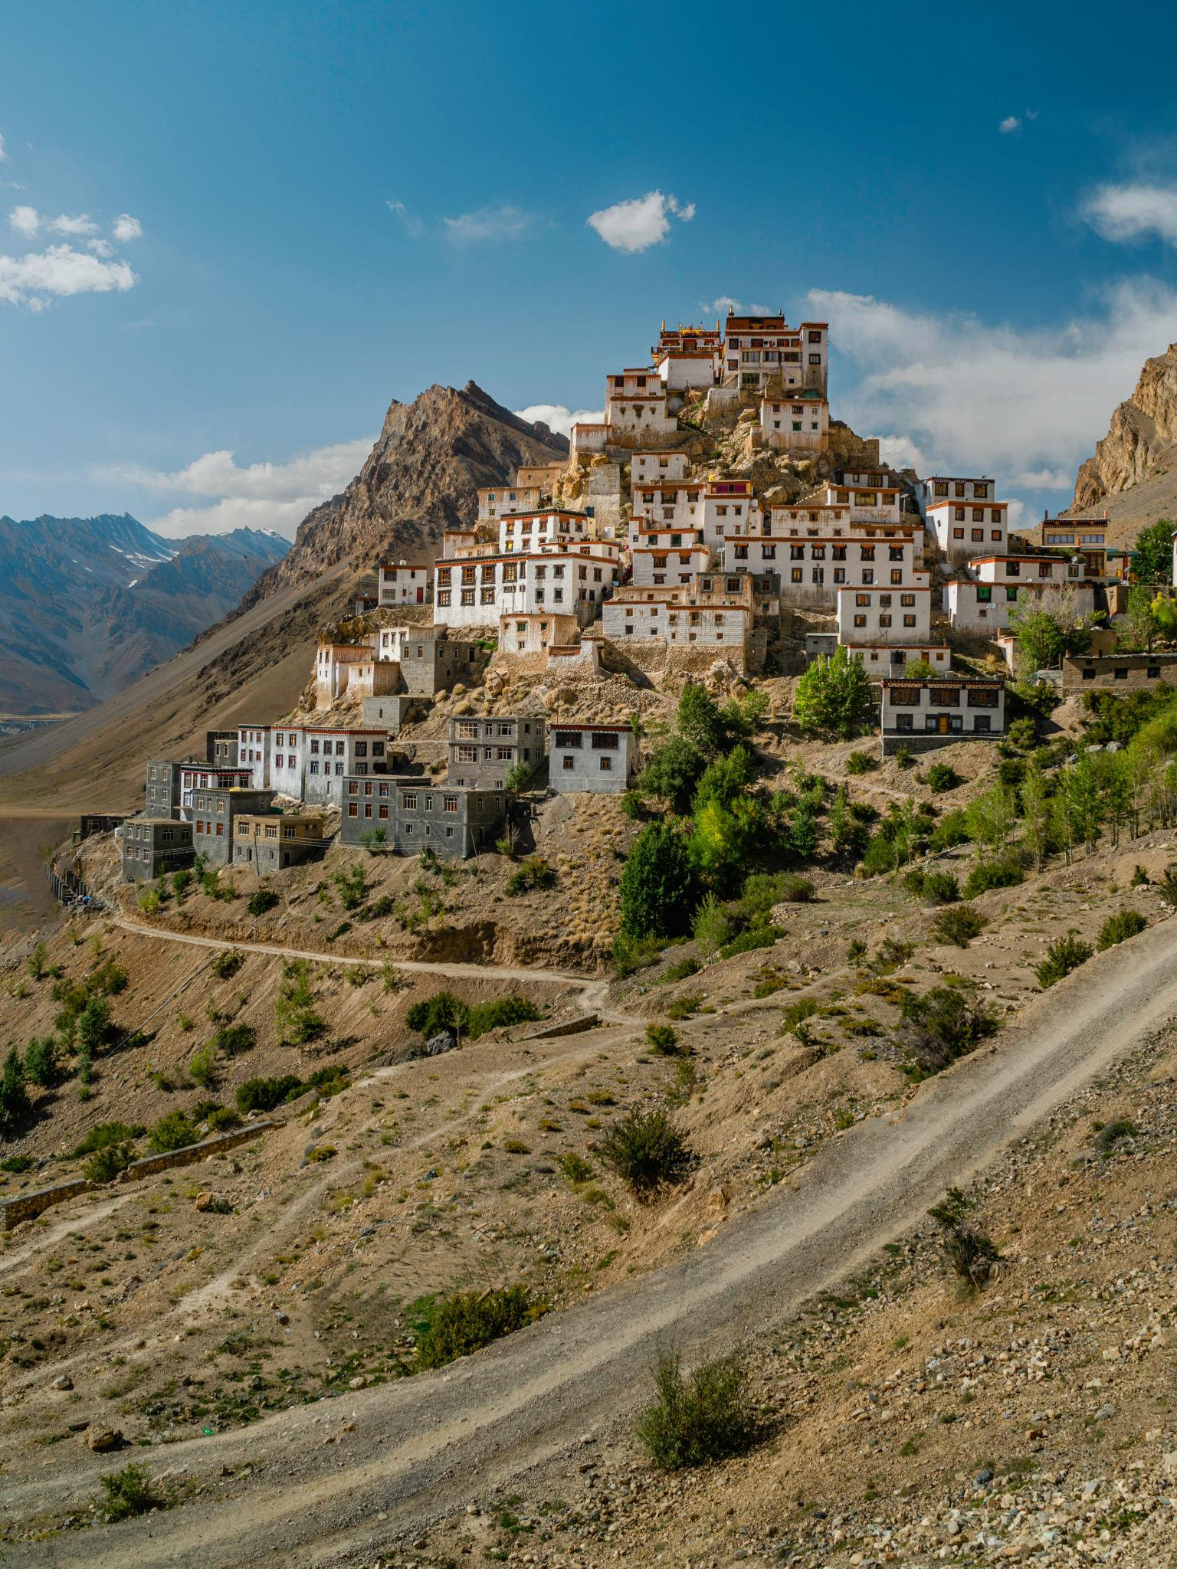
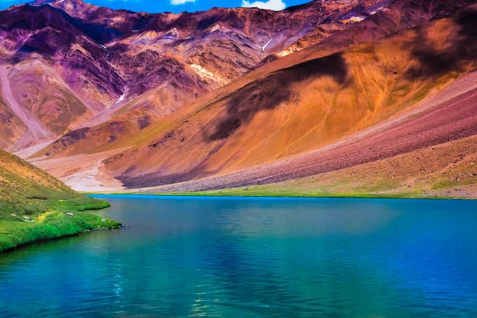
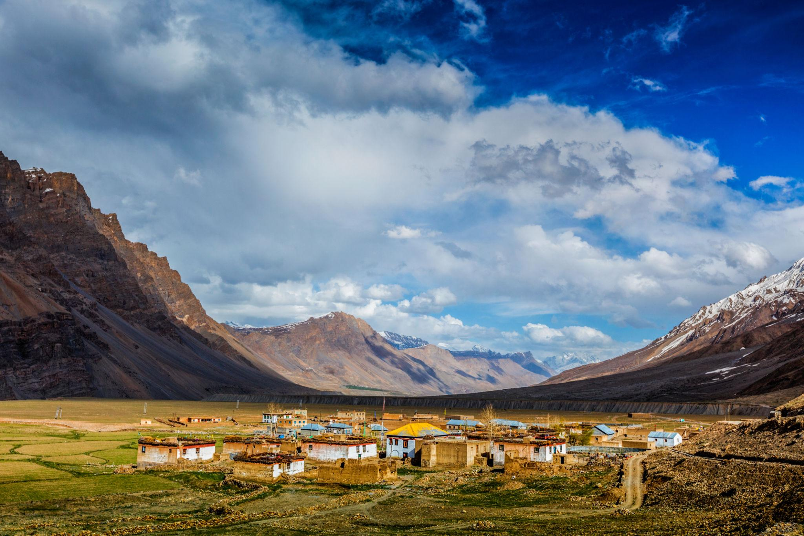
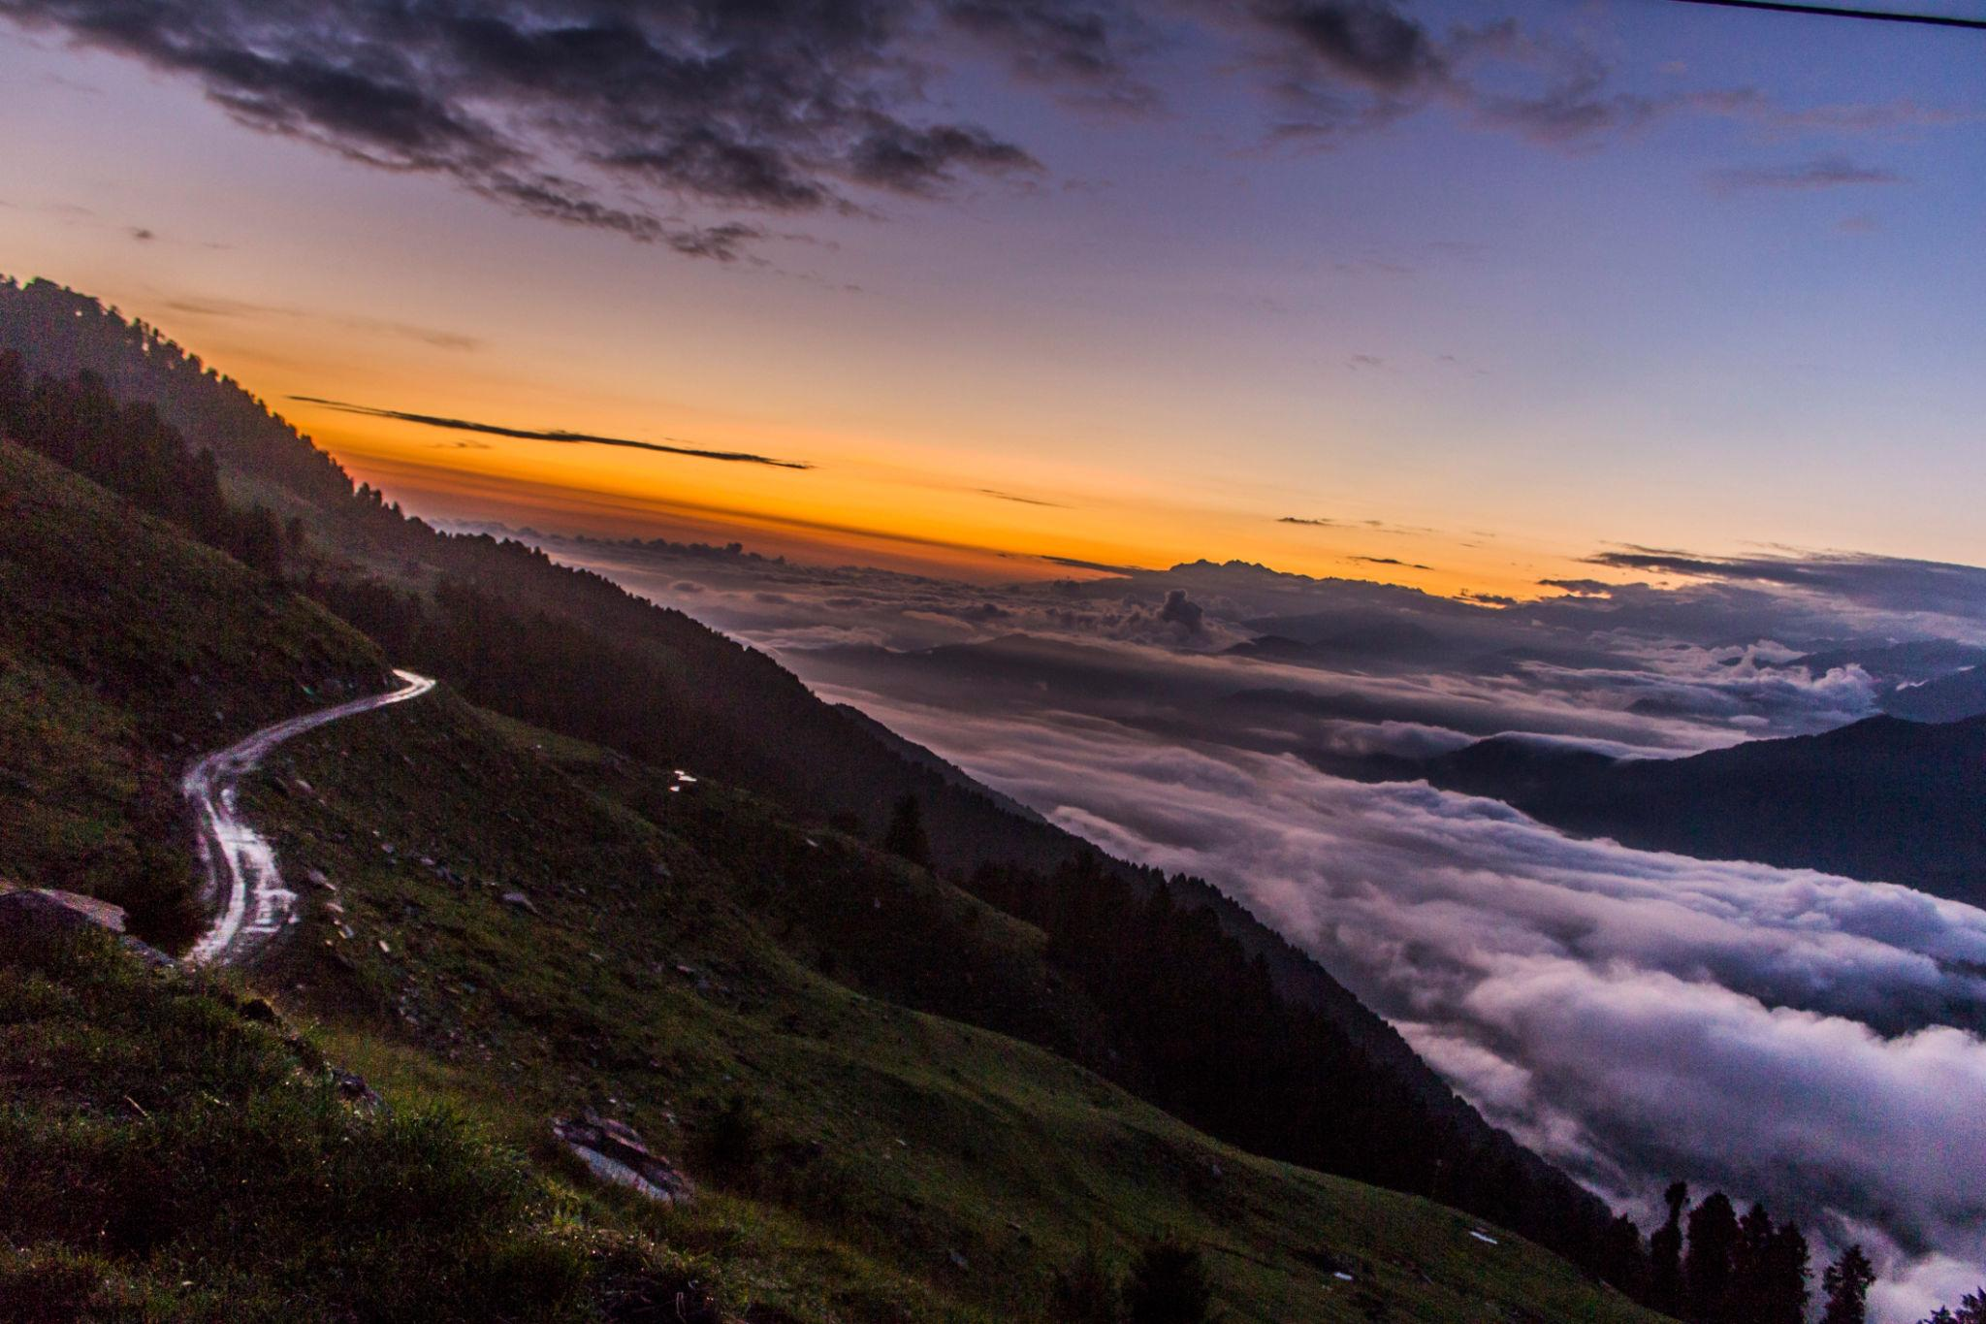
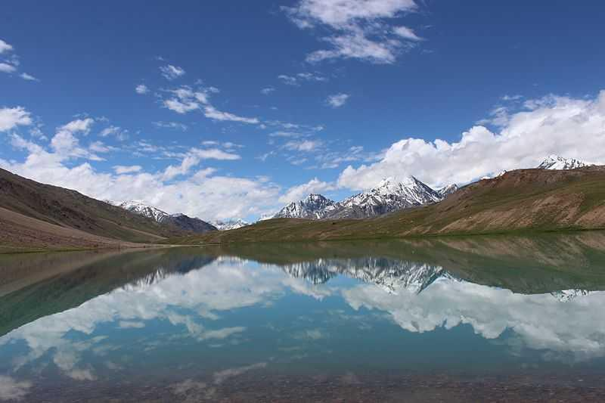
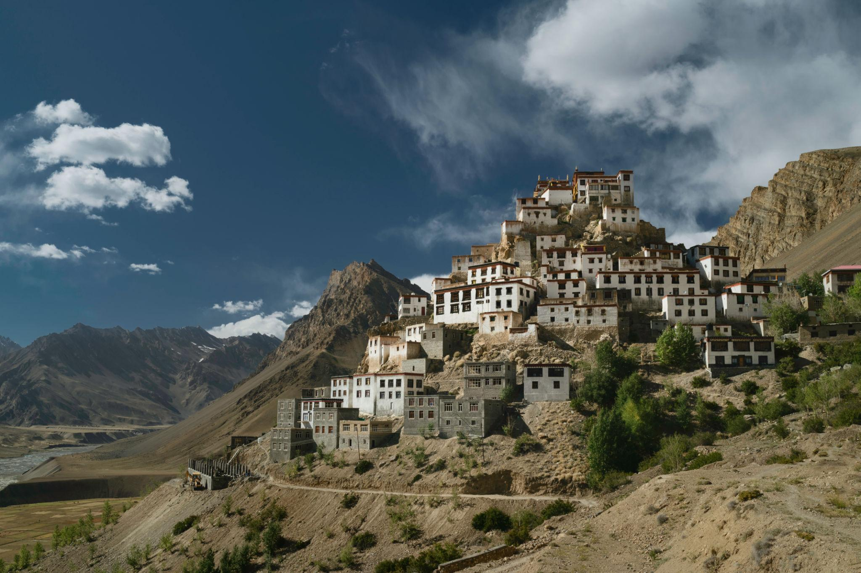
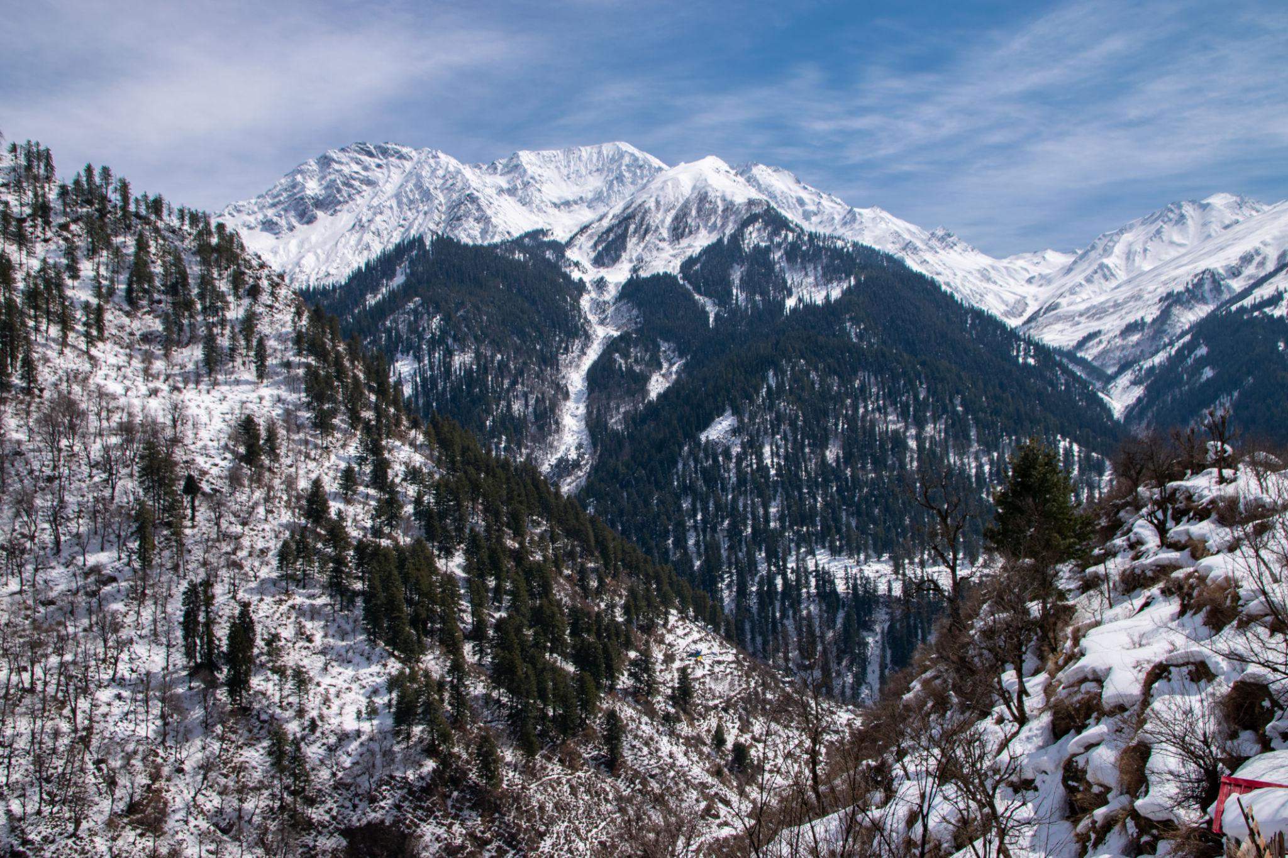

6. Dalhousie
A charming colonial-era hill station surrounded by pine forests.
Highlights:
- Khajjiar
- Colonial architecture
- Scenic viewpoints
- Nature walks
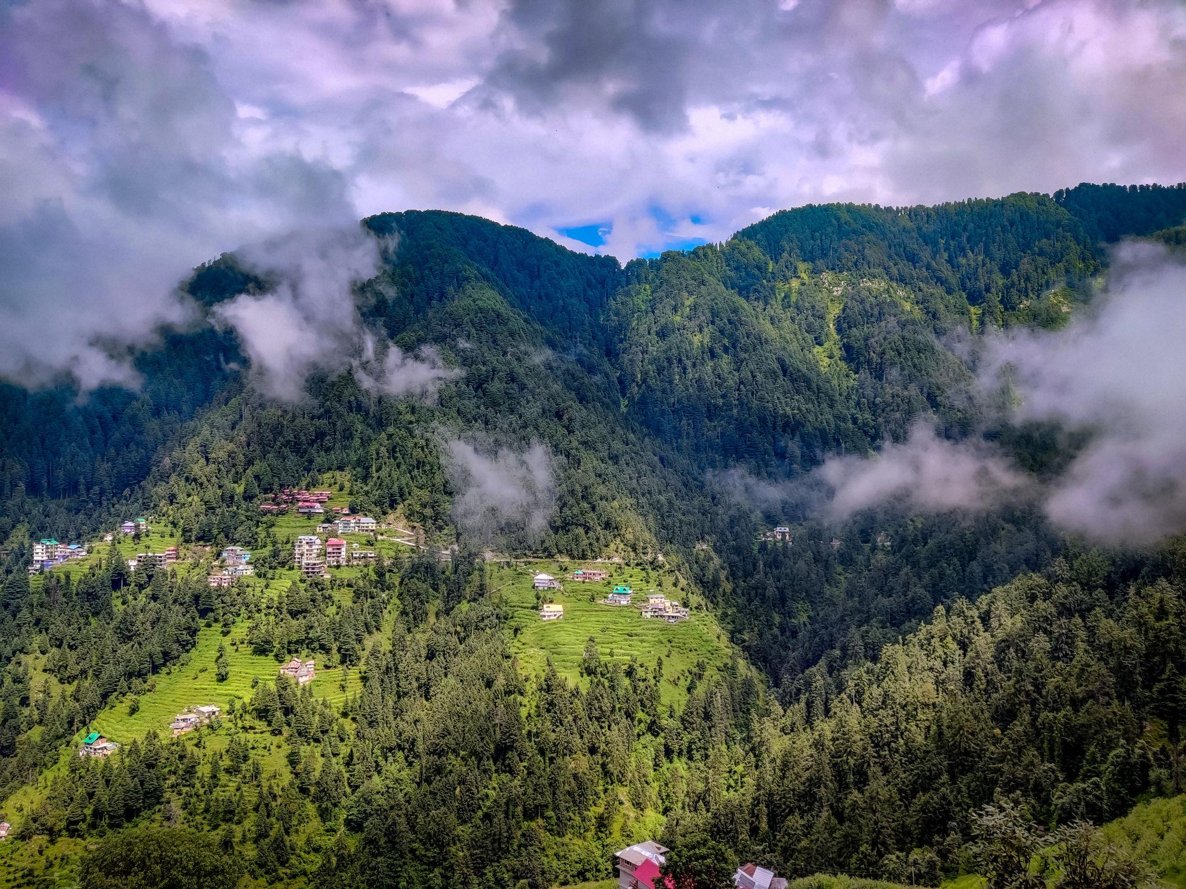
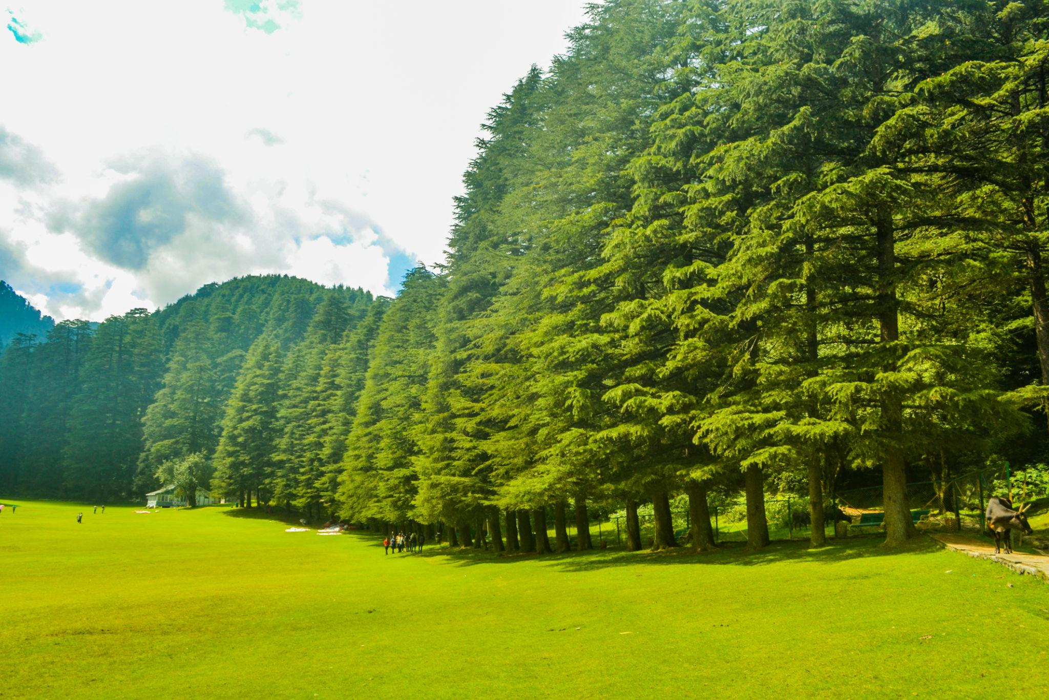
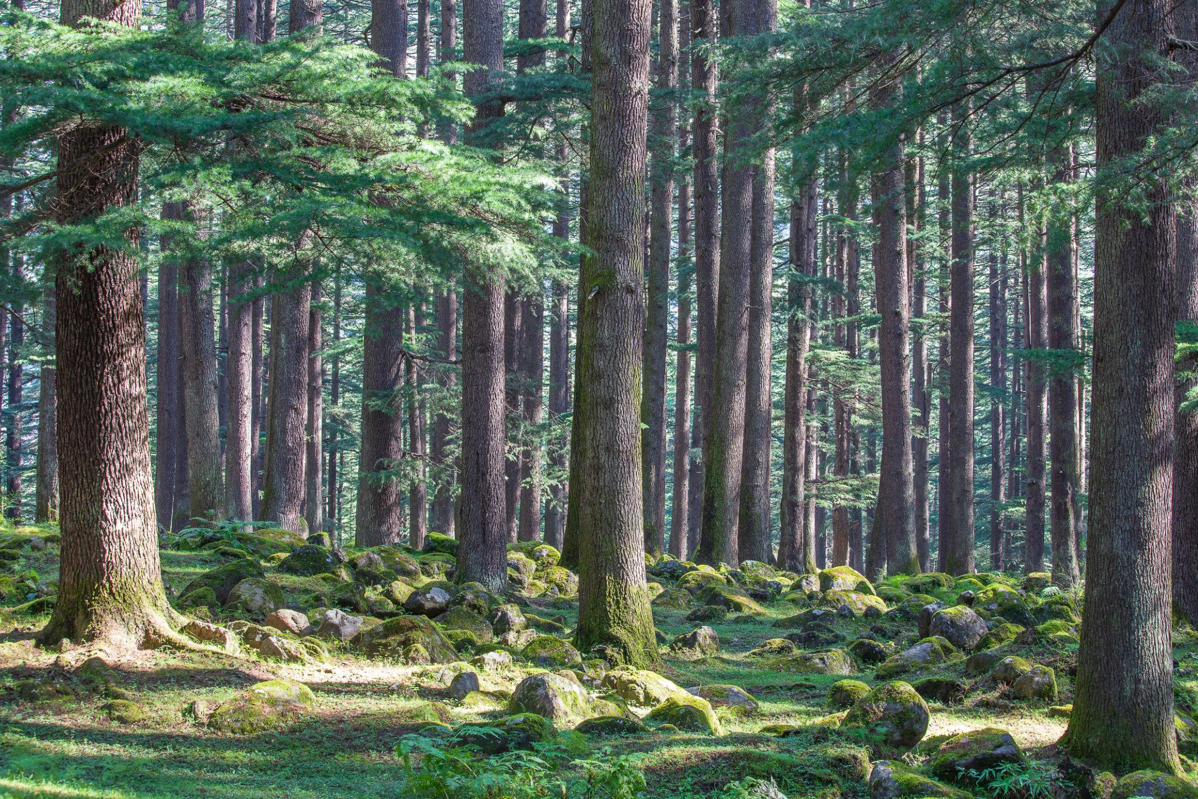
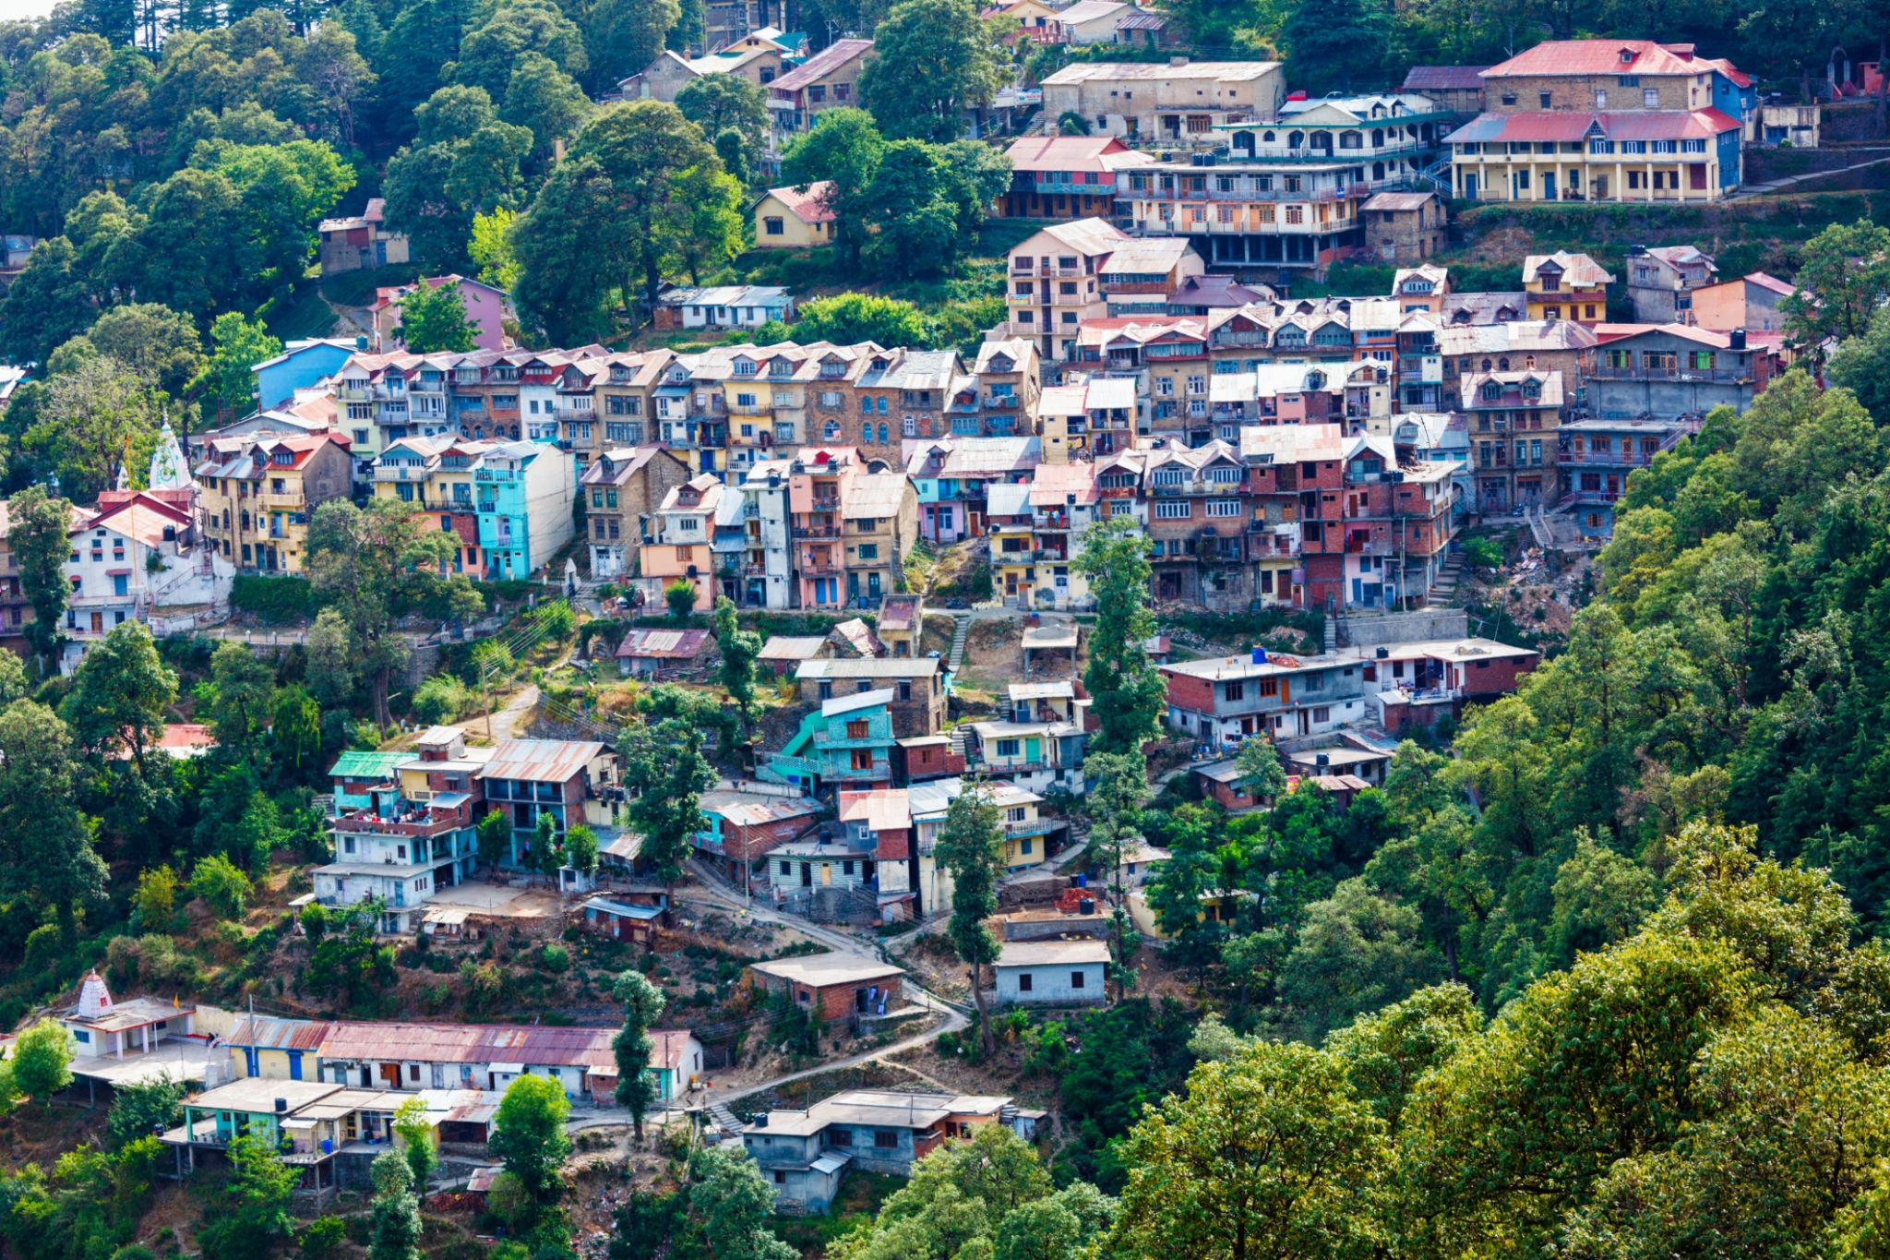
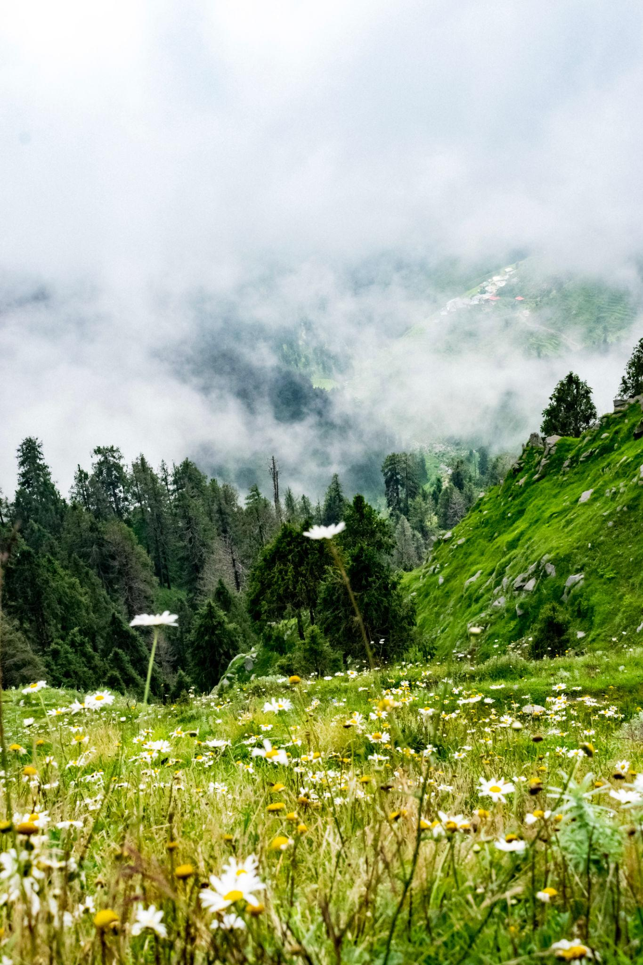
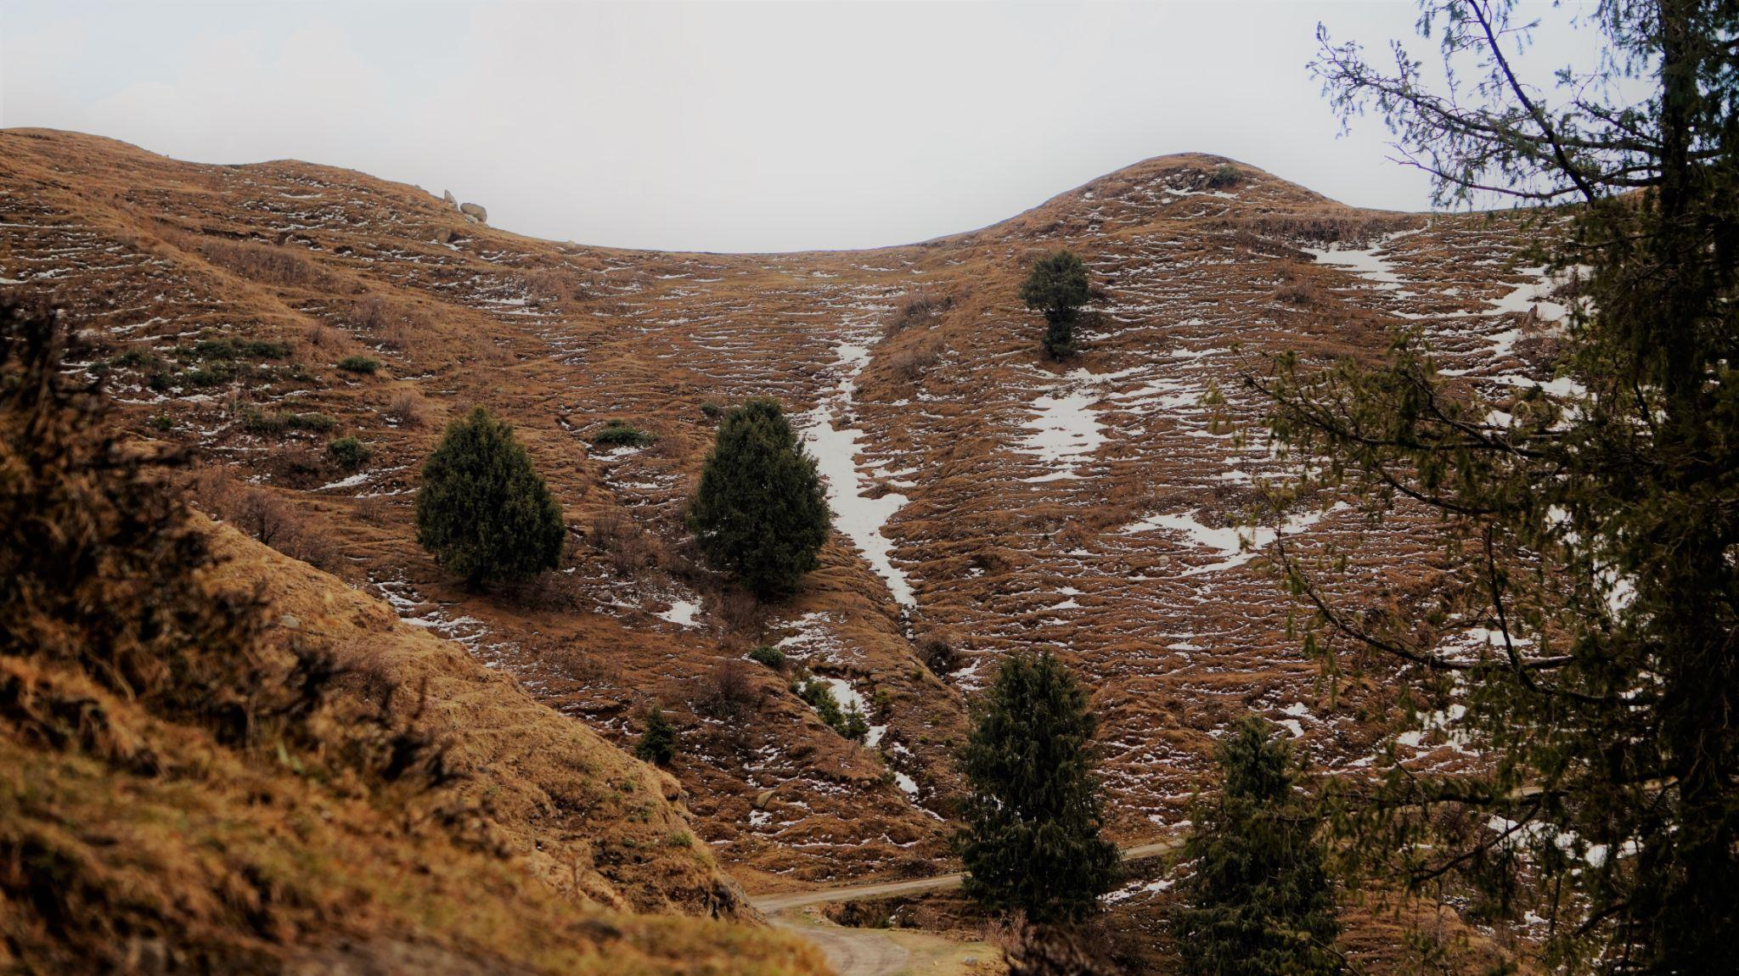

Best Things to Do in Himachal Pradesh
- Enjoy snowfall & mountain views
- Experience paragliding & river rafting
- Trek through Himalayan trails
- Camp beside rivers & valleys
- Visit monasteries & temples
- Ride bikes through scenic mountain roads
- Enjoy café culture & local markets
- Explore wildlife & nature parks

Adventure Activities in Himachal 🏕️
Popular activities:
- Paragliding in Bir Billing
- Skiing in Solang Valley
- River rafting in Kullu
- Camping in Kasol
- Trekking in Triund & Spiti
- Mountain biking
- ATV rides & ziplining
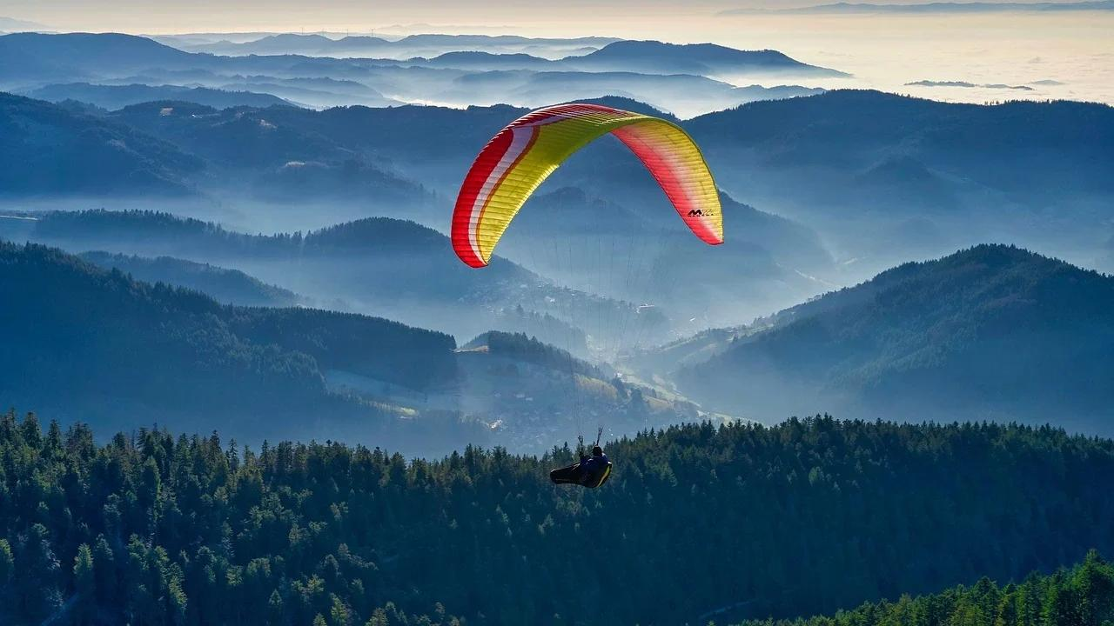
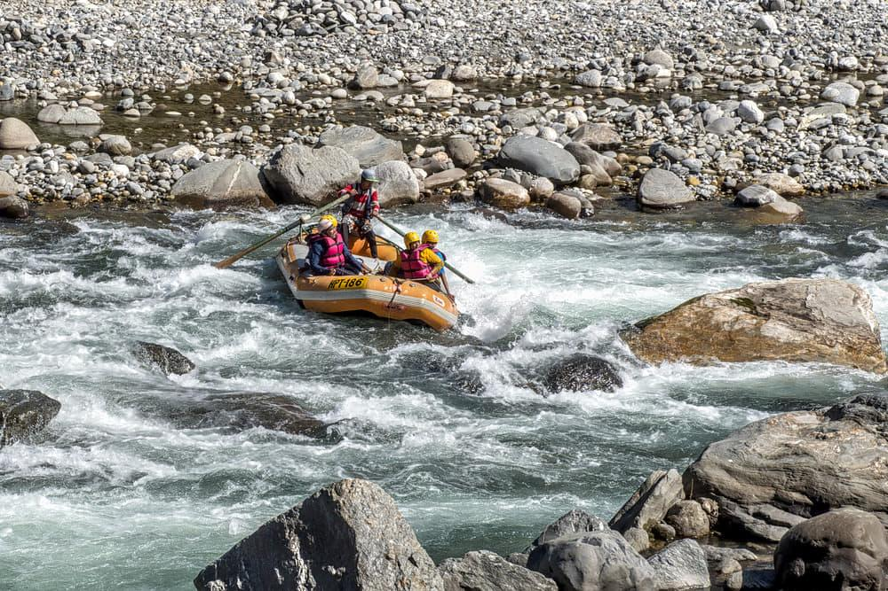
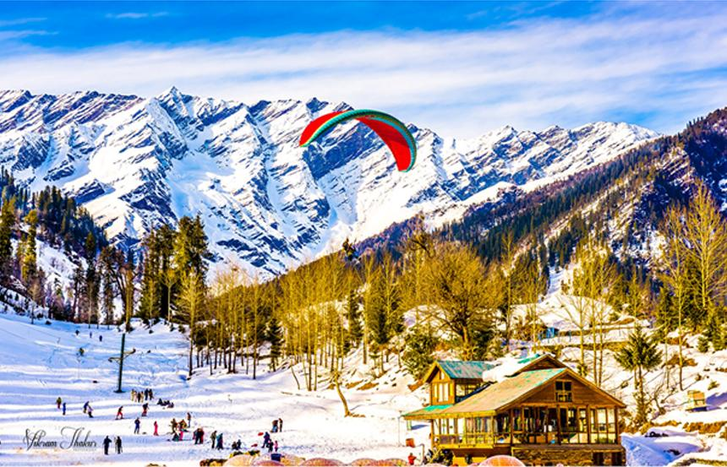
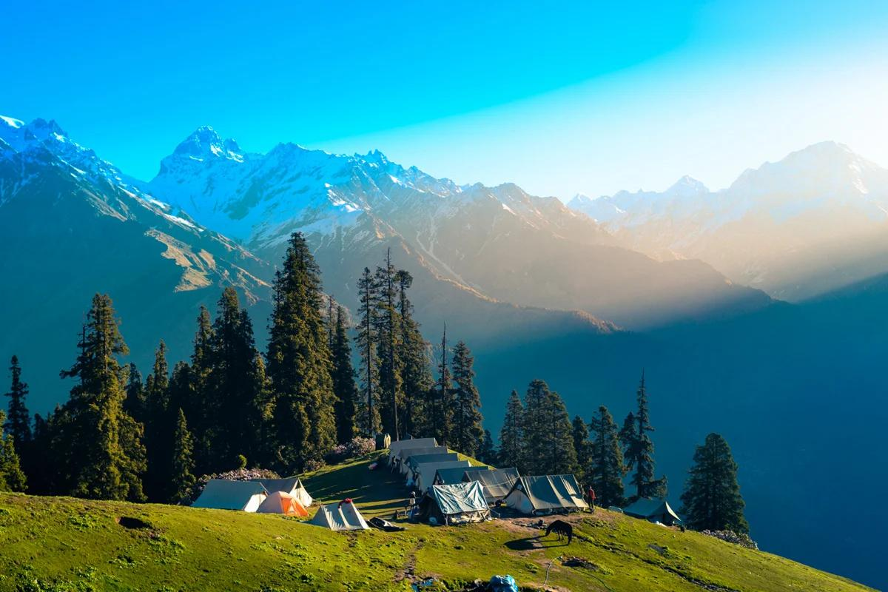
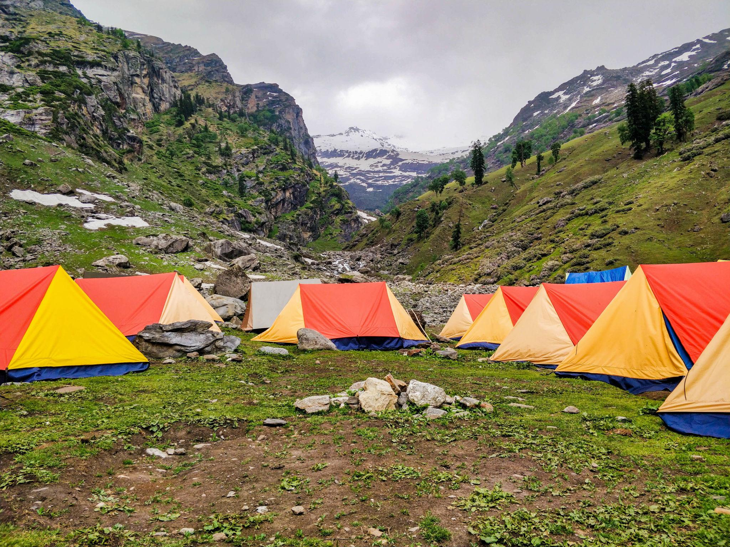
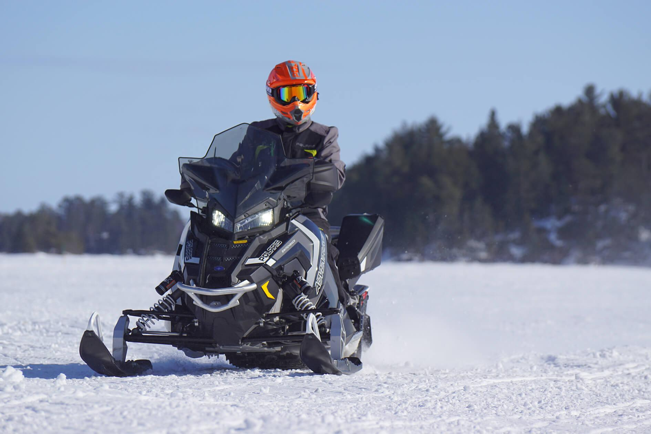

Best Time to Visit Himachal Pradesh
Season | Months | Weather
Summer | March – June | Pleasant & ideal for sightseeing
Monsoon | July – September | Green landscapes & waterfalls
Winter | October – February | Snowfall & winter activities
Winter is best for snow lovers, while summer is ideal for family vacations and sightseeing.

How to Reach Himachal Pradesh
By Air
Major airports:
- Kullu–Manali Airport
- Shimla Airport
- Kangra Airport
By Train
Popular railway connections:
- Kalka to Shimla Toy Train
- Pathankot Railway Station
By Road
Excellent road connectivity from:
- Delhi
- Chandigarh
- Punjab
- Haryana

Famous Foods to Try in Himachal 🍲
- Siddu
- Madra
- Chha Gosht
- Dham
- Tibetan Momos
- Thukpa
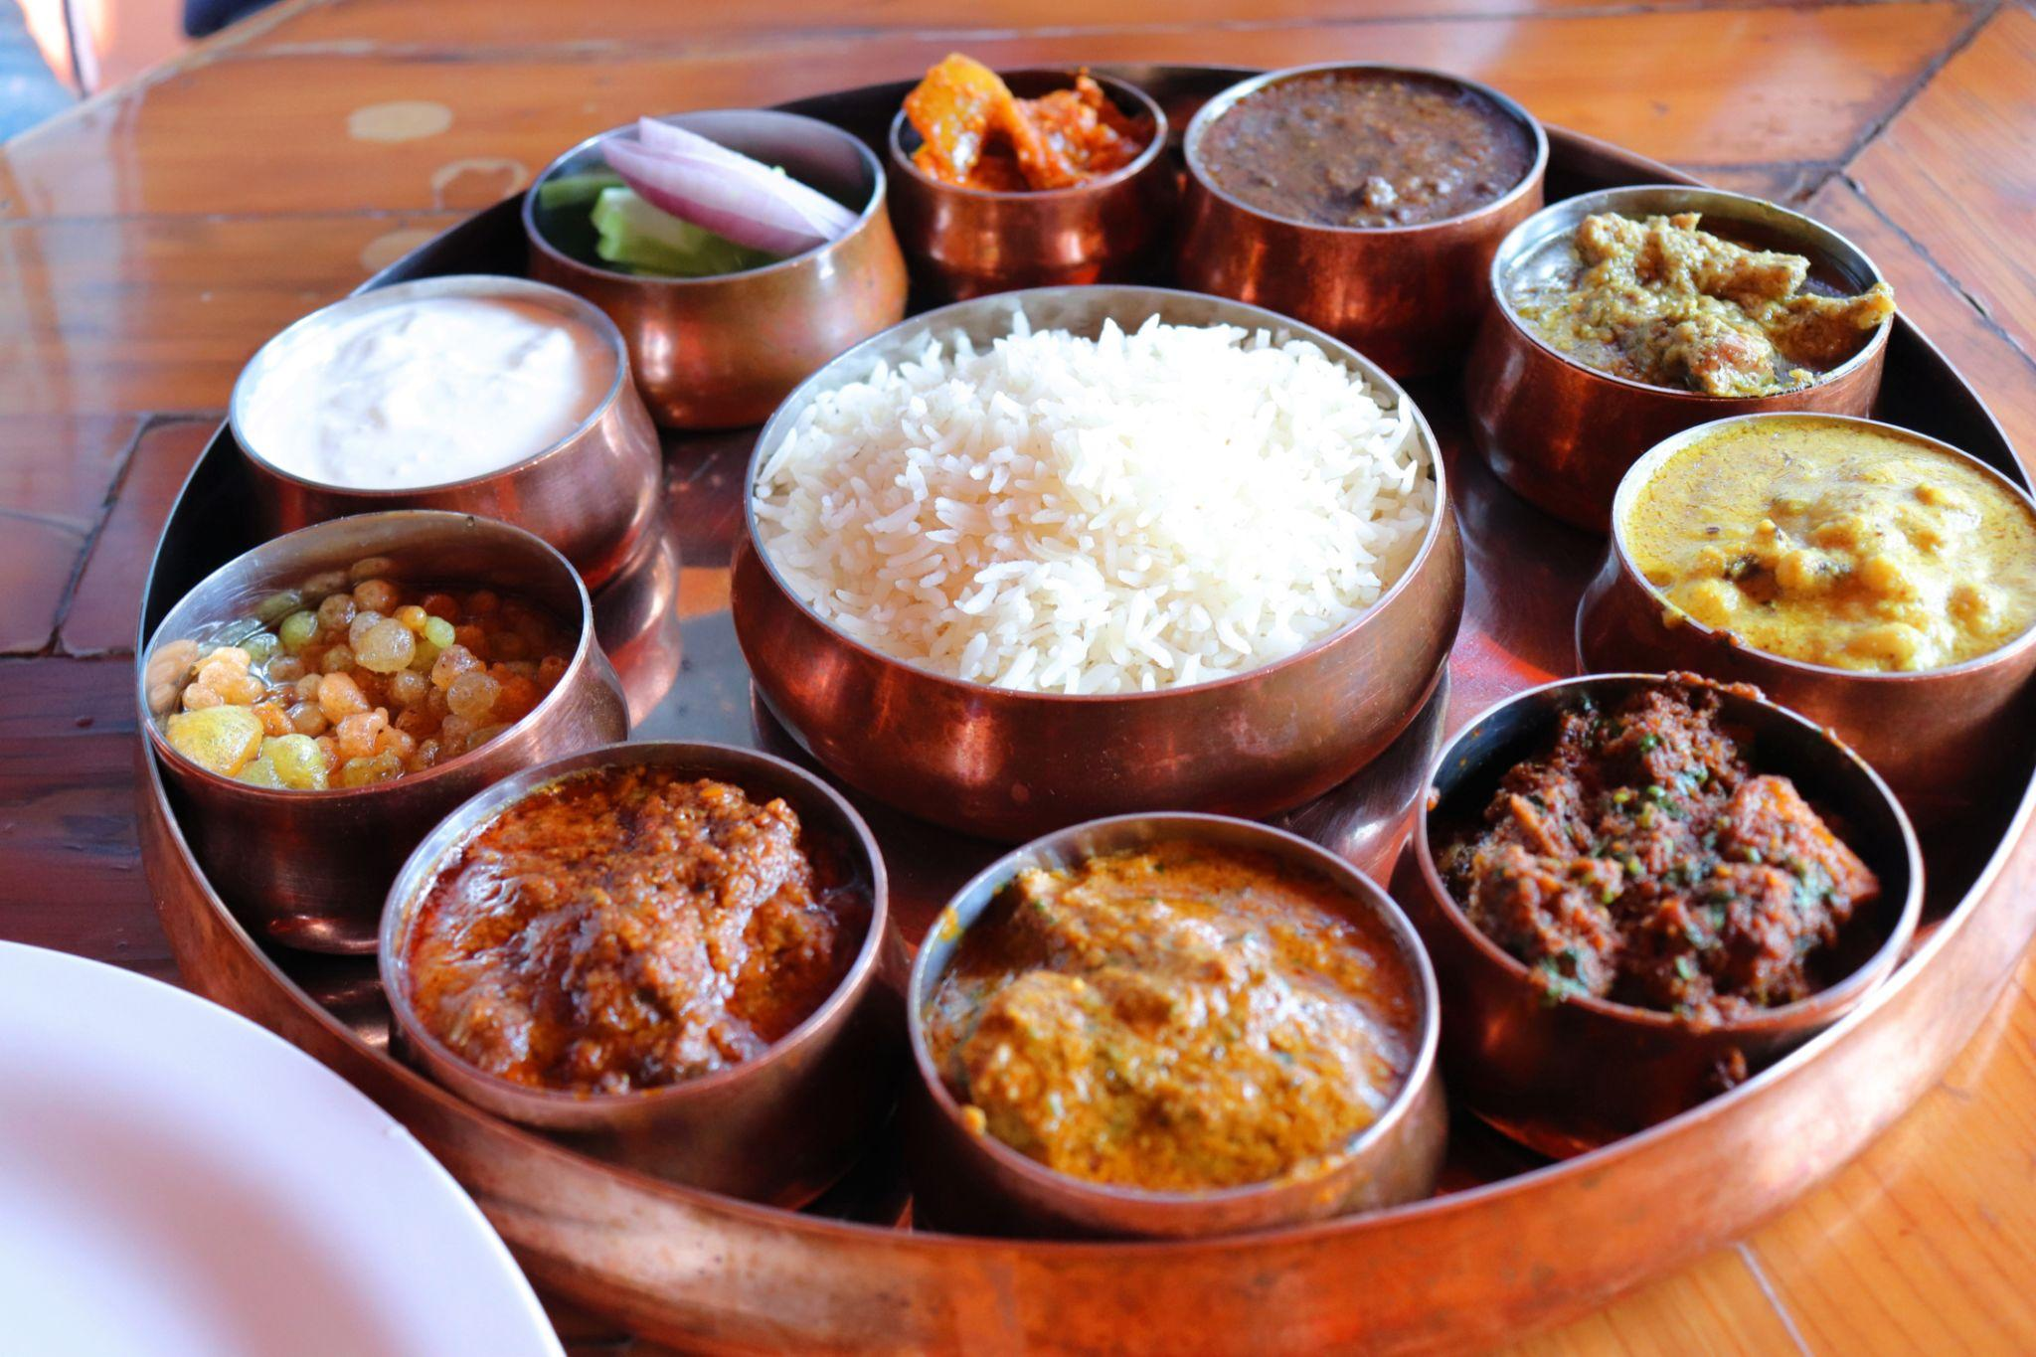

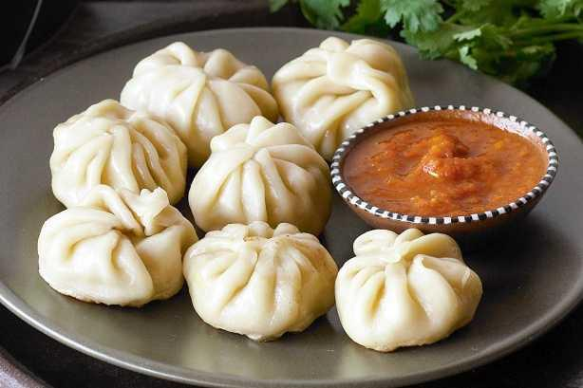
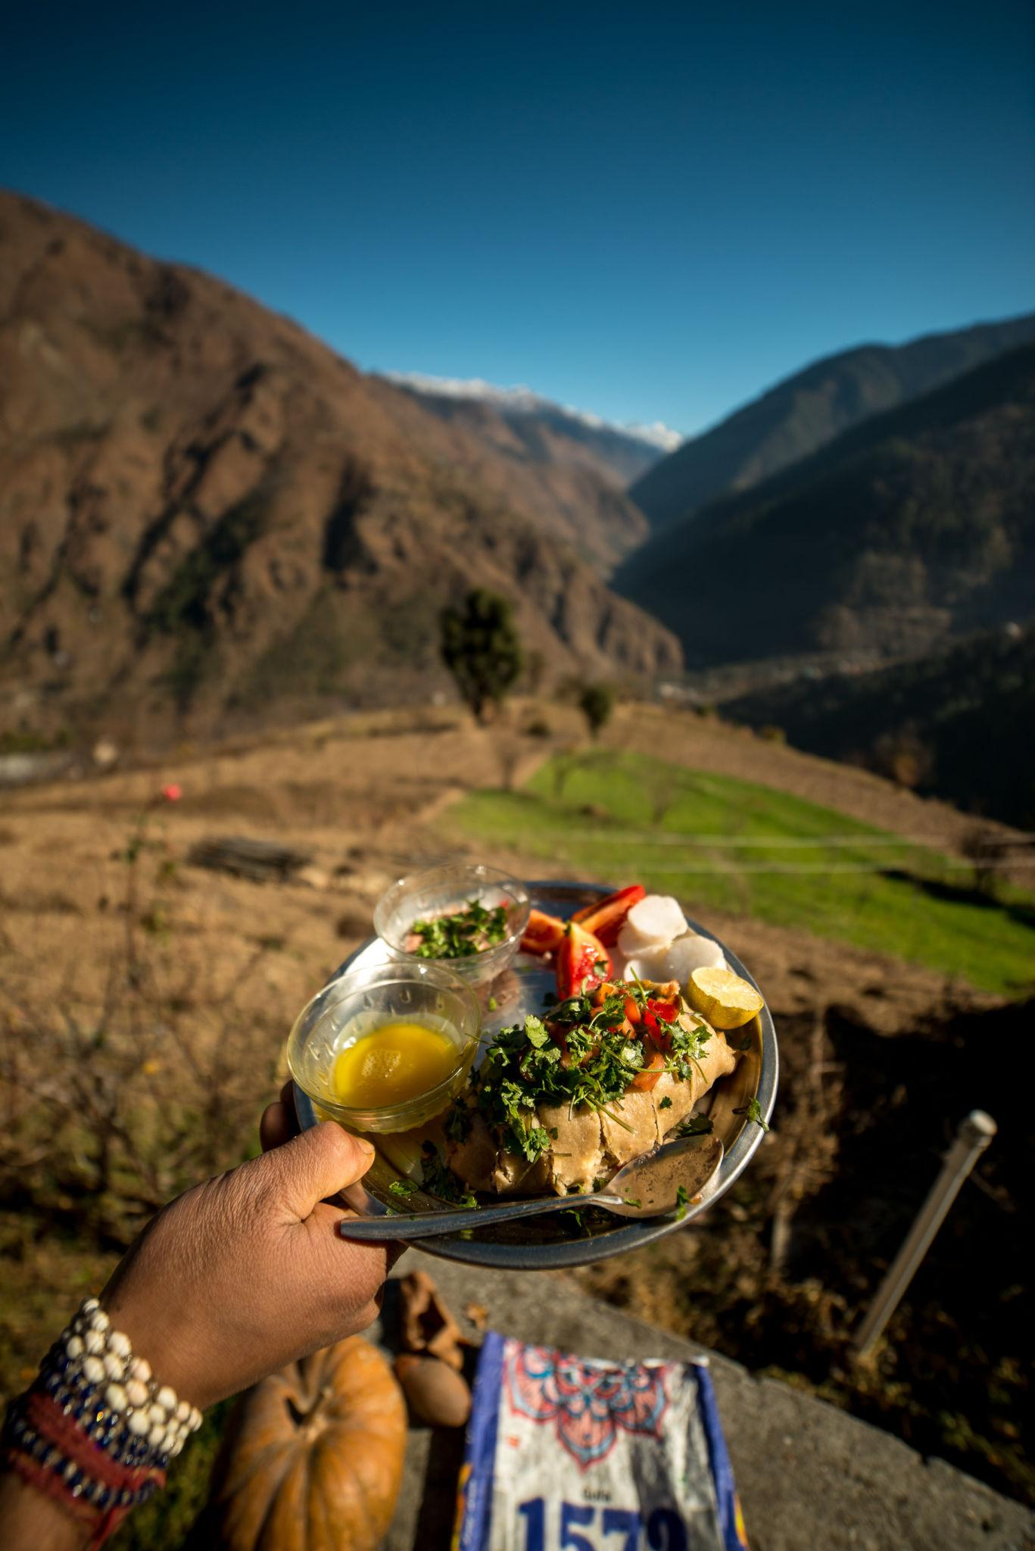
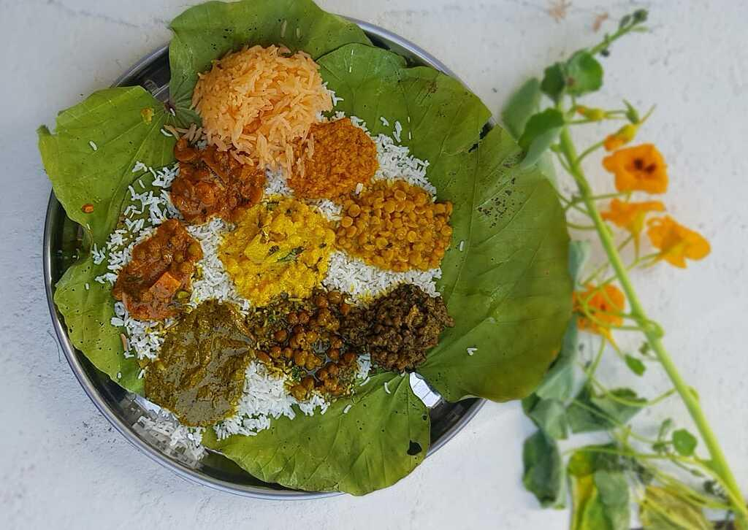
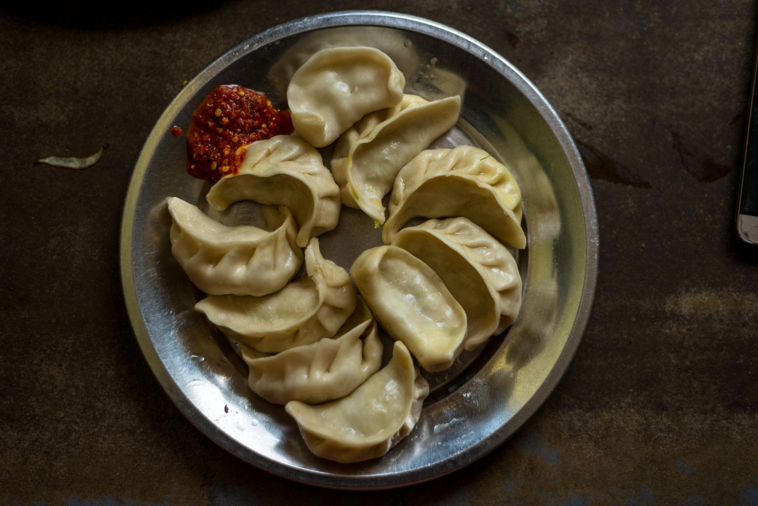

Luxury Experiences in Himachal ✨
- Luxury mountain resorts
- Private riverside cottages
- Spa & wellness retreats
- Premium honeymoon stays
- Luxury camping experiences
- Private adventure tours

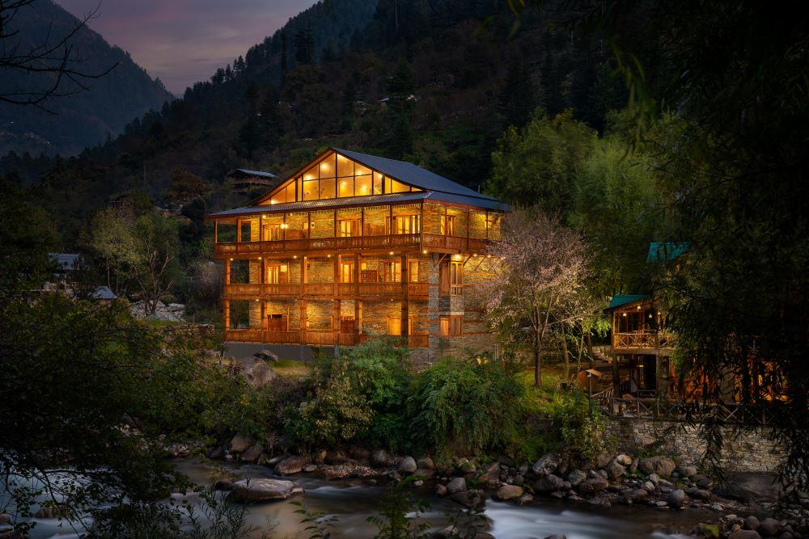
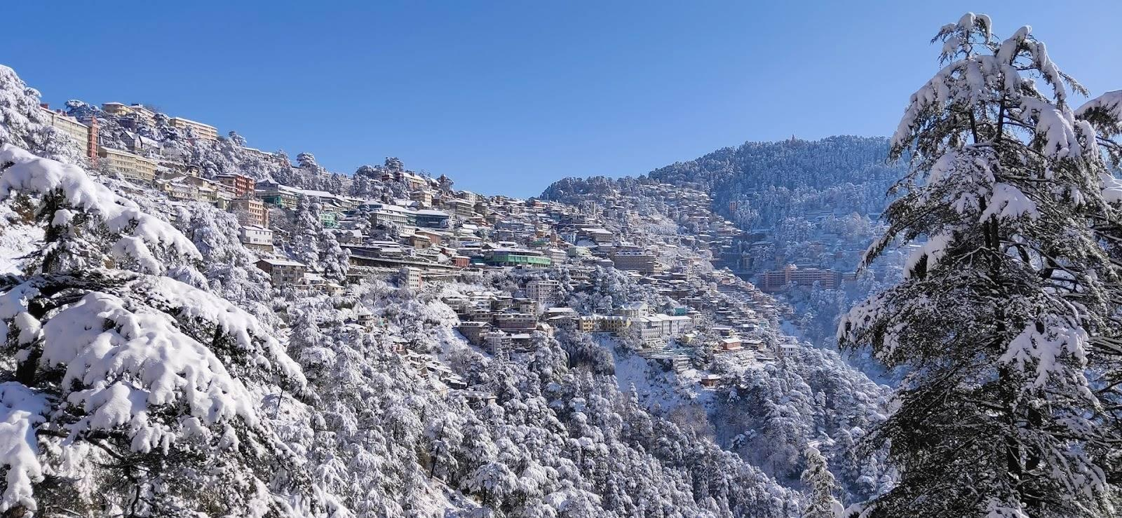
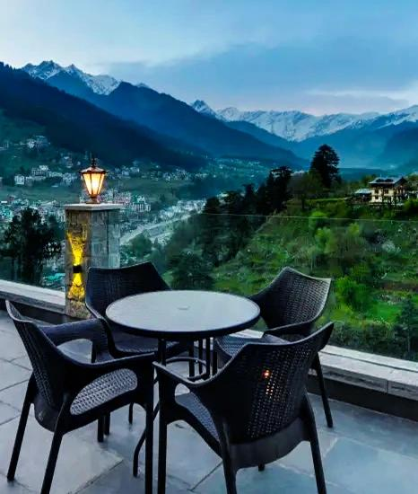
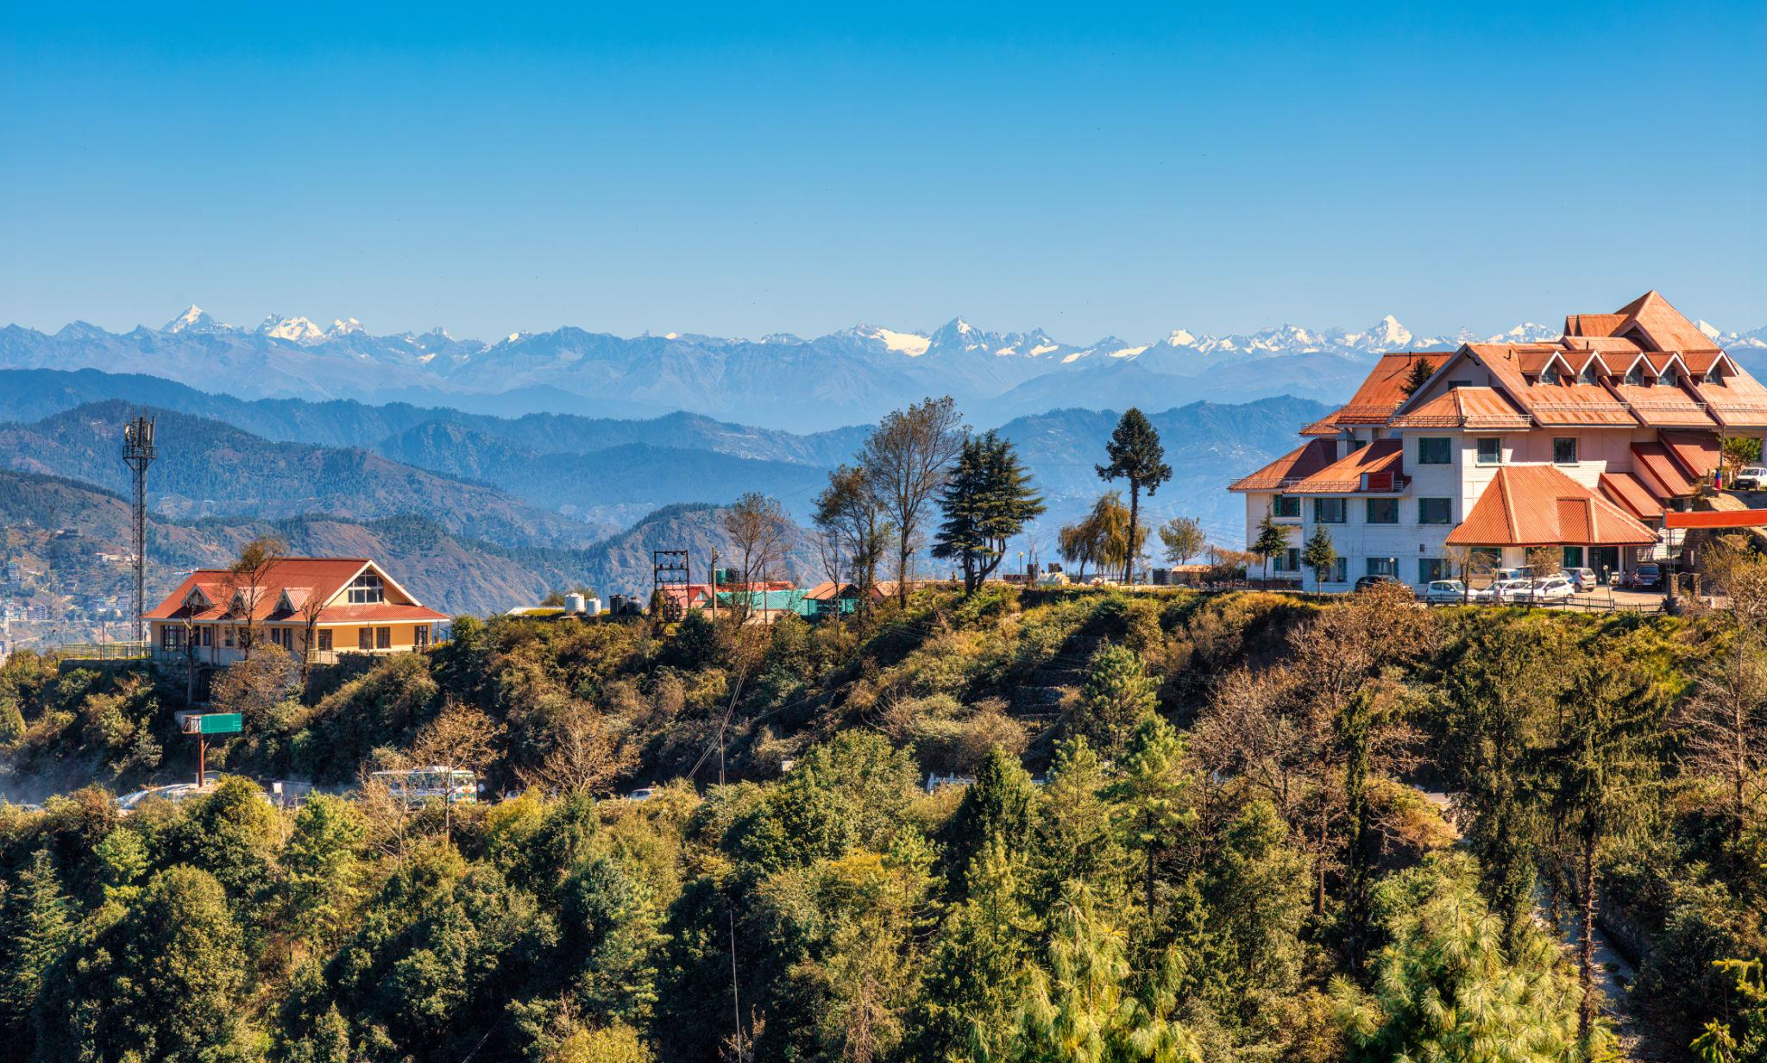
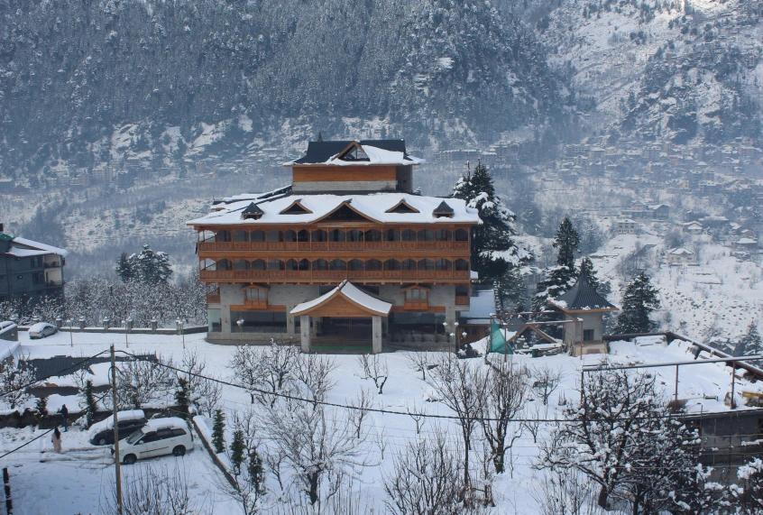
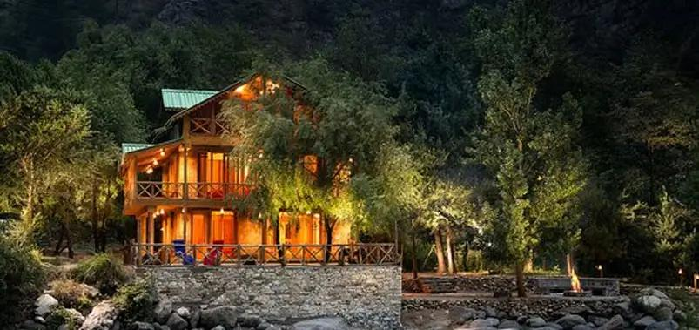
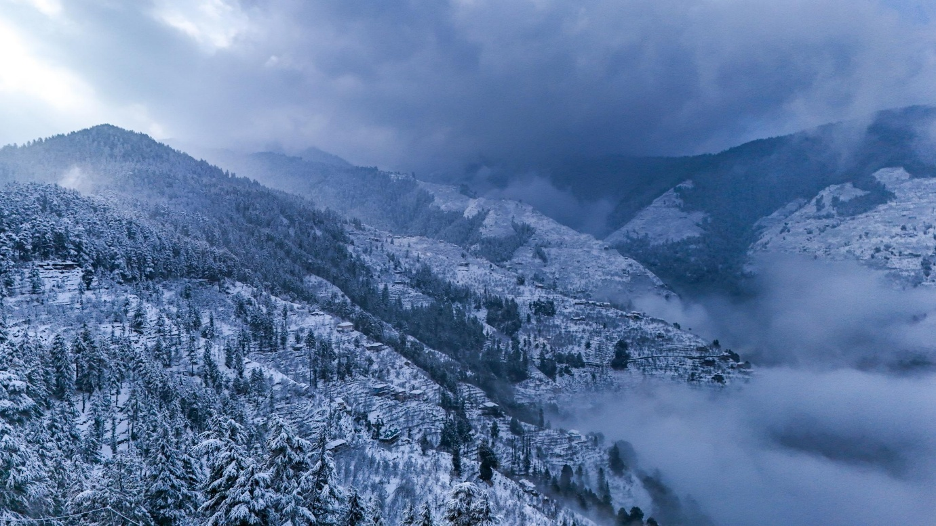
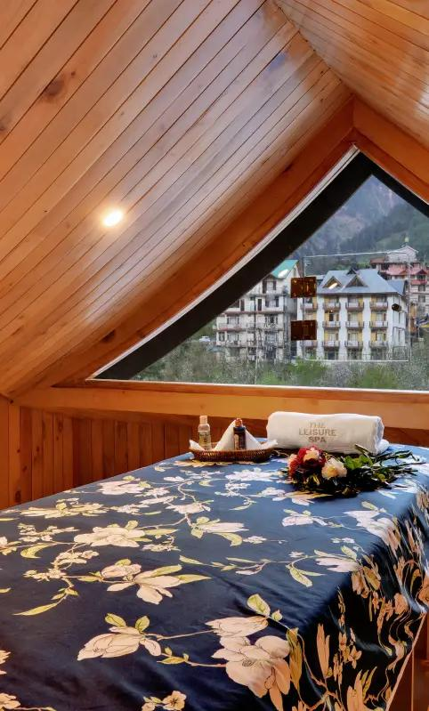

Himachal Travel Tips
- Carry warm clothes in all seasons
- Check weather before mountain travel
- Book hotels early during snowfall season
- Carry comfortable trekking shoes
- Keep essential medicines while traveling to high-altitude regions
- Drive carefully on mountain roads

Why Choose INTRO TRAVELS INDIA for Himachal Pradesh?
With INTRO TRAVELS INDIA, you get:
- Customized Himachal tour packages
- Honeymoon & family holiday tours
- Luxury & budget hotel options
- Adventure activity arrangements
- Guided sightseeing tours
- Comfortable transport services
- Group departures & private tours
- Mountain camping & trekking packages
Himachal Pradesh is a destination where snow-covered mountains, scenic valleys, thrilling adventures, peaceful monasteries, and unforgettable natural beauty come together to create one of India’s most magical travel experiences.

